Benchmarking quantum operations on a high-dimensional nuclear spin qudit in silicon
Xi Yu¹, Rocky Y. Su¹, Danielle Holmes¹, Martin Nurizzo¹, Arjen Vaartjes¹, Yale Fan², Riley J. Murray², Thaddeus D. Ladd³, Kevin Young², Robin Blume-Kohout², Andrea Morello¹
¹School of Electrical Engineering and Telecommunications, UNSW Sydney, Australia
²Quantum Performance Laboratory, Sandia National Laboratories, USA
³HRL Laboratories, LLC, USA

High-dimensional nuclear spin facilitates efficient, compact, and robust schemes for logical encoding and fault-tolerant quantum computation [1,2]. Recent work demonstrated the preparation of Schrödinger cat states in $I = 7/2$ ¹²³Sb donors in silicon, as well as single logical qubit gates by SU(2) operations [3]. However, quantifying error rates for these logical gates in a $d=8$ Hilbert space remains a challenge. Conventional randomized benchmarking (RB), typically applied to Clifford group, is unsuitable because SU(2) operations in high-spin nucleus do not twirl noise into a uniform depolarization channel. Instead, they generate 8 distinct error classes, resulting in the return probability of the RB sequence that follows a mixture of exponential decays.
In this work, we introduce synthetic-SPAM RB, a novel RB variant for SU(2) operations in high-spin nuclei, capable of isolating distinct error classes, each characterized by a single exponential decay. Using this method, we report a no-error rate of 0.975(1) for random SU(2) operations for a single ¹²³Sb donor, highlighting the potential of silicon-based high-spin donor systems for quantum error correction and fault-tolerant computation.

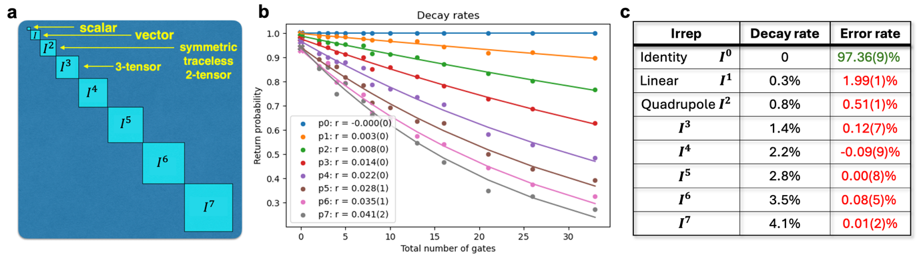
Fig.1 Synthetic-SPAM RB protocol. a, Irreducible representations (irreps, $I= 0,1,2...7$) of the superoperator of SU(2) operations. b, Return probabilities as a function of random SU(2) sequence length, showing one constant and seven distinct exponential decay. c, Table of eight distinct error classes with corresponding decay rate and error rate.

[1] J. A. Gross, Physical Review Letters 127(1) 010504 (2021)
[2] J. A. Gross et al., Physical Review Applied 22, 014006 558(2024)
[3] X. Yu et al., arXiv:2405.15494 (2024)

