Decoupling a singlet-triplet qubit from charge noise
Juan Rojas-Arias¹, Leon C. Camenzind², Yi-Hsien Wu², Peter Stano², Seigo Tarucha^{1,2}, and Daniel Loss^{1,2,3}
¹RIKEN, Center for Quantum Computing (RQC), Wako-shi, Saitama 351-0198, Japan
²RIKEN, Center for Emergent Matter Science (CEMS), Wako-shi, Saitama 351-0198, Japan
³Department of Physics, University of Basel, Klingelbergstrasse 82, CH-4056 Basel, Switzerland

Qubits encoded in the spin states of electrons are promising candidates for the implementation of a quantum computer. However, they require the usage of high-frequency (GHz) equipment that is costly and introduces issues in scalability. Singlet-triplet qubits are an alternative qubit encoding in the states of two interacting spins, that come with characteristic energies of ~MHz and thus are addressable with cheaper instruments and simpler wiring [1]. However, the dependence on exchange interaction makes them particularly sensitive to the effects of charge noise, limiting their coherence and gate fidelities. In this work, we introduce an optimal operation point for a singlet-triplet qubit in the presence of a magnetic field gradient. The proposed “sweet spot” takes advantage of the inherent anti-correlation between exchange interaction and the difference in Zeeman energies of the spins in a uniform magnetic gradient. At the sweet spot, the singlet-triplet qubit becomes insensitive to charge noise, while remaining addressable via electrical driving. This allows for long coherence times, limited by hyperfine coupling to nuclear spins, and high fidelity single-qubit operations. Our findings offer a promising pathway for improving the performance and scalability of quantum processors based on singlet-triplet qubits.

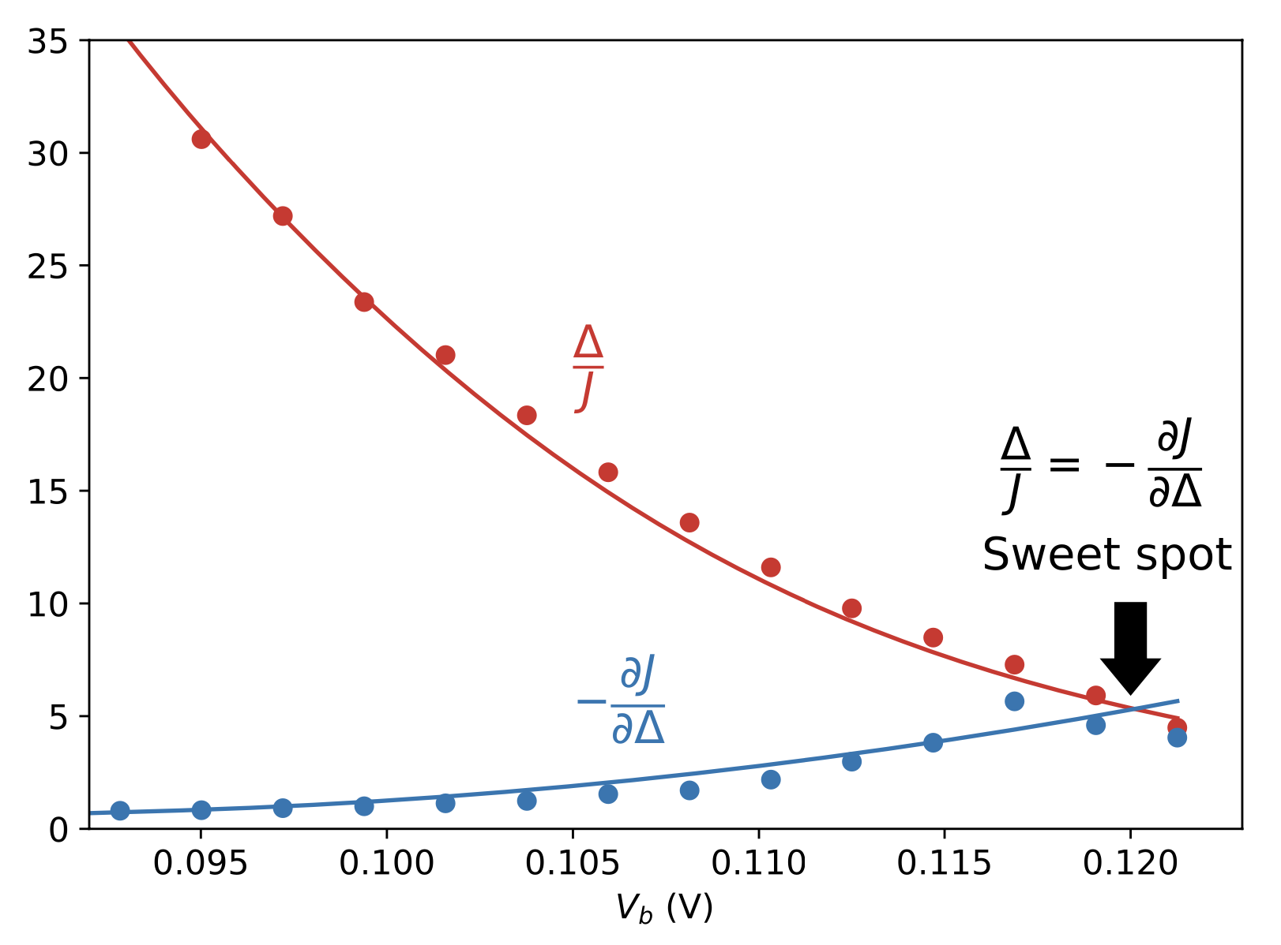
Figure 1, Barrier voltage dependence of the ratio $∆/J$ and the derivative -$∂J/∂∆$, the sweet spot occurs when both quantities take the same value. Here, $∆$ refers to the difference in Zeeman energies between the two spins and $J$ to exchange interaction.

[1] K. Takeda et al. Phys. Rev. Lett. 124, 117701 (2020)

