Coupling of hole double quantum dot in planar germanium to a microwave cavity
Yuan Kang^{1, †}, Zong-Hu Li^{1, †}, Zhen-Zhen Kong², Fang-Ge Li¹, Tian-Yue Hao¹, Ze-Cheng Wei¹, Song-Yan Deng¹, Bao-Chuan Wang¹, Hai-Ou Li¹,Gui-Lei Wang^{2,*},Guang-Can Guo¹, Gang Cao^{1,*}, and Guo-Ping Guo^{1,*}
¹CAS Key Laboratory of Quantum Information, University of Science and Technology of China, Hefei, Anhui 230026, China
²Key Laboratory of Microelectronics Devices & Integrated Technology, Institute of Microelectronics, Chinese Academy of Sciences, Beijing 100029, China

† The authors have equally contributed in this work.
*Corresponding author: gcao@ustc.edu.cn, guilei.wang@bjsamt.org.cn, and gpguo@ustc.edu.cn

In recent years, notable progress has been made in the study of hole qubits in planar germanium, and circuit quantum electrodynamics (circuit QED) has emerged as a promising approach for achieving long-range coupling and scaling up of qubits. Here, we demonstrate the coupling between holes in a planar germanium double quantum dot (DQD) and photons in a microwave cavity. Specifically, a real-time calibrated virtual gate method is developed to characterize this hybrid system, which in turn allows us to determine the typical parameters sequentially through a single-parameter fitting instead of conventional multi-parameter fitting with additional uncertainty, and gives the hole-photon coupling rate of g₀/2π=21.7 MHz. This work is a step toward further research on hole-photon interactions and long-range qubit coupling in planar germanium. The experimental method developed in this work contributes to the more accurate and efficient characterization of hybrid cavity-QED systems[1].

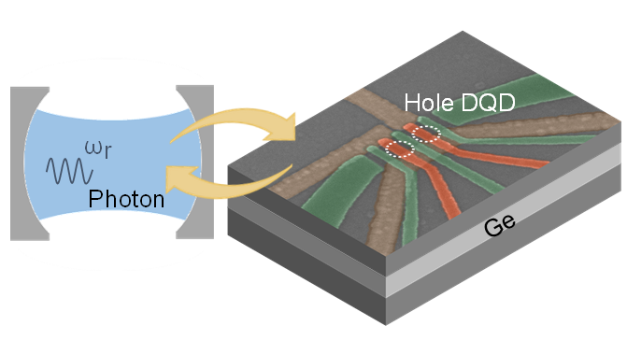
Figure 1, Planar Ge hole DQD coupled to a microwave cavity.

[1] Y. Kang et al. Phys. Rev. Appl. 22, 024054 (2024).

