Hybrid quantum dots for quantum simulation of Kondo lattice models

Praveen Sriram¹, Connie L. Hsueh¹, Tiantian Wang², Candice Thomas², Geoffrey Gardner², Marc A. Kastner¹, Michael J. Manfra², and David Goldhaber-Gordon¹
¹Stanford University, Stanford, California 94305, USA
²Purdue University & Microsoft Quantum Lab Purdue, West Lafayette, Indiana 47907, USA
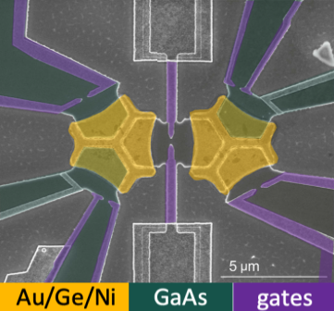
Fig 1 : False colored scanning electron microscope image of the two-site hybrid metal-GaAs quantum dot device from [1].
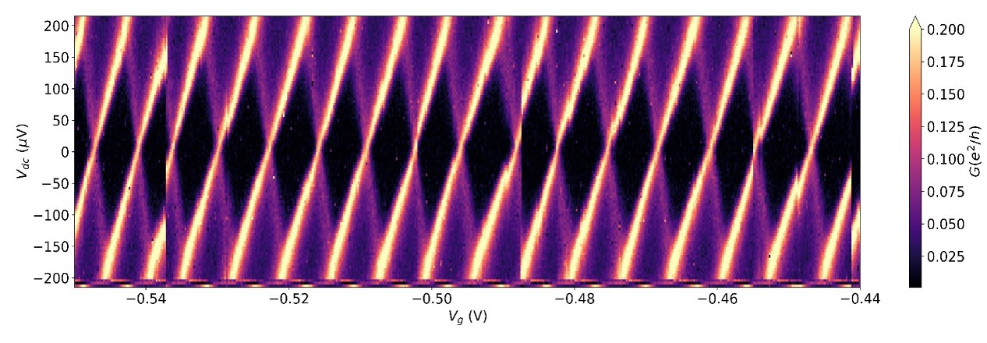
Few-site semiconductor quantum dot arrays have provided controllable realizations of effective Hamiltonians of interest for understanding correlated electron behavior in exotic materials. To connect to bulk material properties, scaling to larger arrays will be important. The biggest challenge in doing this is intrinsic dot-to-dot inhomogeneity. A new type of hybrid metal-semiconductor quantum dot may solve this problem. The quasi-continuous level spectrum of a nanoscale metal island enables each site to behave essentially identically, while the semiconductor component still allows tuning intersite coupling. Recent experiments with hybrid metal-GaAs quantum dots investigated a non-Fermi liquid quantum critical point (QCP) between competing ‘charge’-Kondo ground states[1]. Scaling this to many such sites will allow simulating Kondo lattice models and testing ideas for explaining lattice coherence in heavy-fermion materials.
Fig 2 : Coulomb diamonds of the hybrid InAs dot with a quasi-continuous spectrum and charging energy = 200 μV.
Vp (V)

In a hybrid dot, melding a metallic density of states with the tunability granted by a semiconductor requires a near-perfect submicron ohmic contact between metal island and semiconductor quantum well. This is a formidable challenge: the islands in Fig.1 (on a GaAs heterostructure) had to be a few microns wide, restricting investigations of the critical point to a narrow temperature range below the charging energy.

InAs offers the prospect of more miniaturized ohmic contacts: Fermi level pinning obviates the need for high-temperature annealing, a major source of inhomogeneous contact morphology. We report the fabrication and characterization of hybrid metal-InAs quantum dots, featuring a submicron metallic island with tunable couplings to macroscopic reservoirs. In the quantum Hall regime, a near-perfect interface transparency (>99.8%) is measured for the outermost edge mode. Quantum point contacts (QPCs) provide electric control of the dot-reservoir couplings. At weak tunneling we measure charge quantization with strong uniformity in Coulomb peaks, no resolvable excitation spectrum in the Coulomb diamonds (Fig 2.), and a four-fold enhancement in the charging energy over the GaAs platform. We have demonstrated among the cleanest QPCs in InAs [2] and have tuned the coupling strengths to reveal the evolution from static to dynamical Coulomb blockade, with charge quantization fully quenched when QPCs are opened to transmit a full mode. Our work positions hybrid metal-InAs dots as a promising platform for making arrays of functionally-identical sites to gain insights into Kondo lattice coherence.
[1] Pouse, W., Peeters, L., Hsueh, C.L. et al. Nat. Phys. 19, 492–499 (2023).
[2] Hsueh, C.L.*, Sriram, P.*, et al. Phys. Rev. B 105, 195303 (2022)

