Quantum Machine Learning for Semiconductor Fabrication: Modeling GaN HEMT Contact Process
Zeheng Wang^{1,†}, Fangzhou Wang², Liang Li³, Zirui Wang³, Timothy van der Laan¹, Ross C. C. Leon⁴, Jing-Kai Huang⁵, and Muhammad Usman^{1,6}
¹CSIRO, Australia, (†email: zenwang@outlook.com); ²Songshan Lake Materials Laboratory, China; ³Peking University, China; ⁴Quantum Motion, UK; ⁵City University of Hong Kong, China; ⁶University of Melbourne, Australia.
Quantum computing (QC) is widely regarded as a promising solution for many problems that classical computers cannot efficiently solve. However, in the noisy intermediate-scale quantum (NISQ) era, QC's fundamental unit, the quantum bit (qubit), still faces challenges related to limited integration and low fidelity, hindering the implementation of error-correction algorithms necessary for universal QC. Consequently, current QC applications are often limited to specific functions, such as quantum sampling, rather than universal quantum algorithms. Quantum machine learning (QML) stands out as one of the most promising applications of QC in the NISQ era [1], [2]. Unlike classical computers, QML leverages quantum variational algorithms and quantum kernel algorithms, which are more resilient to data noise and can map classical data into quantum space. This capability accelerates computations and uncovers subtle data patterns [3], making QML particularly effective for modeling small-scale, imbalanced data sets—a common challenge in semiconductor research.
In this study, we design, optimize, benchmark, and experimentally verify a quantum kernel-based regressor (QKR) to model the process of Ohmic contacts in GaN high-electron-mobility transistors (HEMTs), a key process that determines the device’s performance. We extracted 159 experimental results from previously published literature to train and test our model. Our optimized QML model was benchmarked against six mainstream CML methods. Additionally, we conducted additional experiments to externally verify our QML model. The results demonstrate that our QML model exhibits superior performance compared to the CML methods. In external verification, the model achieved a mean absolute error (MAE) of 0.314 Ω∙mm, significantly below the reference threshold and other CML models’ results, indicating the high potential of QML for semiconductor research and industrial applications.
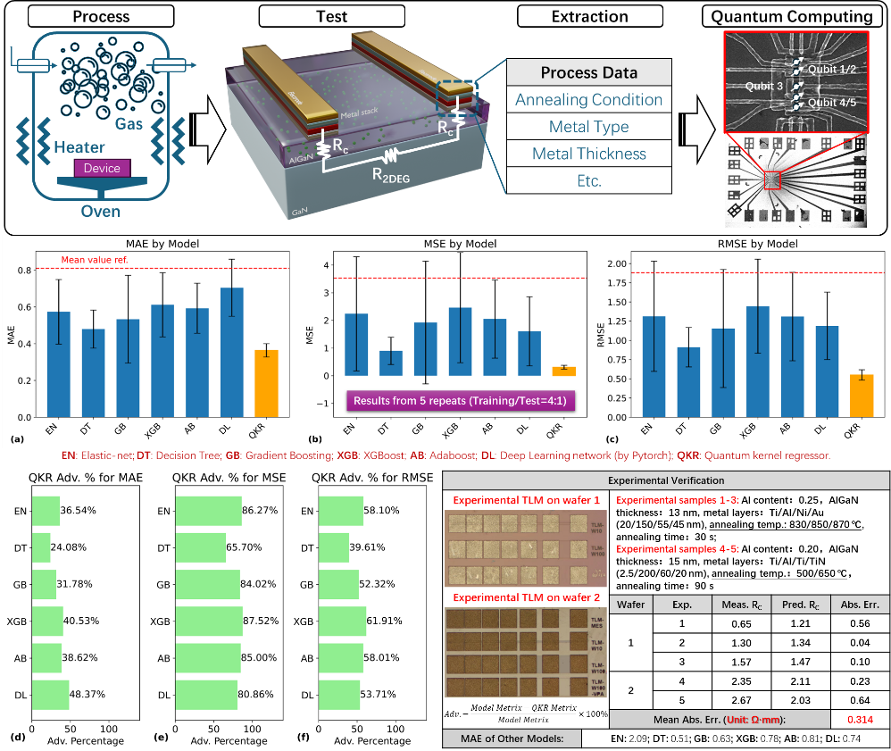
Figure 1, Workflow and key results. The QML algorithm is designed to be deployed in spin qubits.
[1] J. Biamonte et al., Nature, vol. 549, no. 7671, pp. 195–202, Sep. 2017. [2] M. Cerezo et al., Nat Comput Sci, vol. 2, no. 9, pp. 567–576, Sep. 2022. [3] J. R. Glick et al., Nat. Phys., Jan. 2024.

