Violating Bell’s inequality

in gate-defined quantum dots
Paul Steinacker¹, Tuomo Tanttu^{1,2}, Wee Han Lim^{1,2}, Nard Dumoulin Stuyck^{1,2}, MengKe Feng^{1,2}, Santiago Serrano^{1,2}, Ensar Vahapoglu^{1,2}, Rocky Y. Su¹, Jonathan Y. Huang¹, Cameron Jones¹, Kohei M. Itoh³, Fay E. Hudson^{1,2}, Christoper C. Escott^{1,2}, Andrea Morello¹, Andre Saraiva^{1,2}, Chih Hwan Yang^{1,2}, Andrew Dzurak^{1,2}, Arne Laucht^{1,2}
¹First School of Electrical Engineering and Telecommunications, UNSW, Sydney, Australia
²Diraq, Sydney, NSW, Australia
³School of Fundamental Science and Technology, Keio University, Yokohama, Japan

The superior computational power promised by quantum computers utilises the fundamental quantum mechanical principle of entanglement.
However, achieving entanglement and verifying that the generated state does not follow the principle of local causality has proven difficult for spin qubits in gate-defined quantum dots, as it requires simultaneously high concurrence values and readout fidelities to break the classical bound imposed by Bell's inequality.
Here we employ advanced operational protocols for spin qubits in silicon, such as heralded initialization and calibration via gate set tomography (GST) [1-3], to reduce all relevant errors and push the fidelities of the full 2-qubit gate set above 99%. We demonstrate a 97.17% Bell state fidelity without correcting for readout errors and violate Bell's inequality with a Bell signal of S = 2.731 close to the theoretical maximum of 2$\sqrt{2}$. Our measurements exceed the classical limit even at elevated temperatures of 1.1 K or entanglement lifetimes of 100 μs.
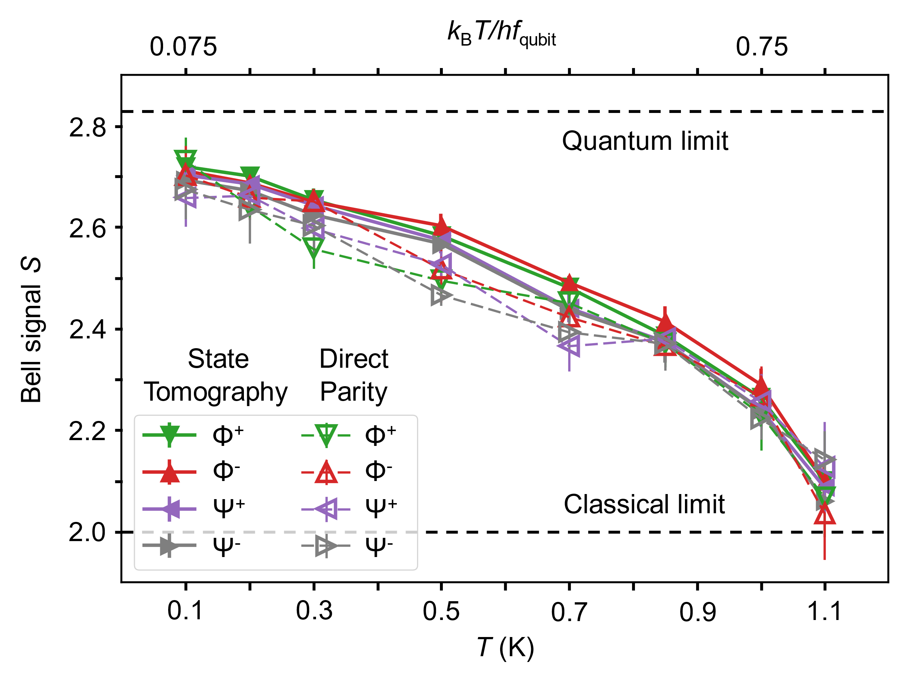
Figure 1, SQ6 logo. (Arial 10 Italic)

[1] R. Blume-Kohout et al., Nat. Comm. 8, 14485 (2016)
[2] E. Nielsen et al., Quantum 5, 557 (2021)
[3] T. Tanttu et al., arXiv:2303.04090

