Ensembles of ion implanted donor spins in ion beam enriched silicon
David Jamieson^{1,3}, Alexander Jakob^{1,3}, Shao Qi Lim^{1,3}, Ravi Acharya^{1,4}, Daneille Holmes^{2,3}, Andrea Morello Holmes^{2,3}, Dane McCamey³, Richrd Curry⁴
¹University of Melbourne
³University of New South Wales
³Centre for Quantum Computation and Communication Technology
⁴University of Manchester

We have developed a simple method to enrich silicon in which the ²⁹Si non-zero nuclear spin isotope ($I=1/2$, natural abundance 4.67%) is depleted in favour of the zero nuclear spin ²⁸Si isotope ($I=0$, 92.2%). We employ high fluence ²⁸Si ion implantation, from either a standard ion implantation system found in university laboratories and semiconductor foundries or a highly focused ion beam system. We seek to configure robust, long-lived coherent donor atom spin states in the highly enriched material by depletion of the ²⁹Si nuclear magnetic moments. Guided by ion-solid computer simulations that predict one-for-one sputtering with 45 keV ²⁸Si ion beams, for broad beam fluences above 1E18 ²⁸Si/cm² ²⁹Si depletion is below 150 ppm and an unprecedented 2.3 ppm for fluences above1E19 ²⁸Si/cm² in the focused beam samples [1], both of which are free from isobar contamination (CO, N₂) to the limit of detection. Post-irradiation annealing restores the crystallinity of the samples resulting in a ~200 nm layer of high purity ²⁸Si on both bulk and 220 nm silicon-on-insulator substrates. We employ high sensitivity Electrically Detected Magnetic Resonance to show narrowing implanted ³¹P ensemble hyperfine linewidths as ²⁹Si is depleted in our localised enriched volumes. Independently, we have demonstrated deterministic ³¹PF₂ single molecule implants with 99.99% conﬁdence for near surface qubits [2]. Similar conﬁdence is retained for single ¹²³Sb and ²⁰⁹Bi donors [3] which represent high-dimensional qudits for quantum information processing. We demonstrate the construction of regular arrays of donor atoms with 300 nm spacing using step-and-repeat implantation through an AFM nanostencil. Integration of these techniques provide the requirements for the construction of large-scale, donor-based quantum computer in silicon.
Acknowledgements: ARC grant DP220103467, Royal Society (UK) Wolfson Visiting Fellowship RSWVF/211016, EPSRC grants EP/R025576/1, EP/V001914/1, EP/R00661X/1, co-workers at the University of Manchester (FIB, SIMS, TEM): M Coke, M Adshead, K Li, B Achinuq, R Cai, AB Gholizadeh, J Jacobs, JL Boland, SJ Haigh, KL Moore and the University of Melbourne (ion implantation, EDMR, TEM): JC McCallum, S Rubanov.
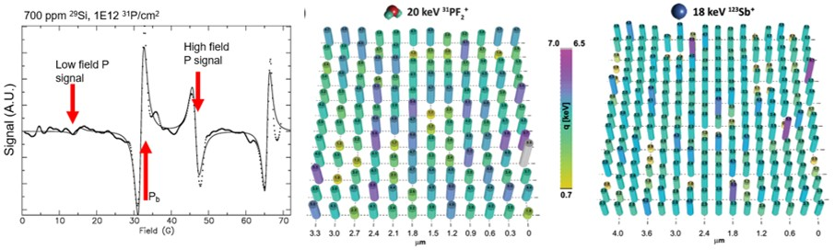
Figure 1 (L-R)) EDMR of P implanted 700 ppm ²⁹Si, PF₂ and Sb single implants, 300 nm pitch.
[1] R Acharya, et al, Comm. Mat.5:57 (2024)
[2] D Holmes, et al., Adv. Quant. Tech. 7 202300316 (2024)
[3] AM Jakob, et al., Adv. Mat. 202405006 (2024)

