Variability of hole spin qubits in planar Germanium
Biel Martinez¹, Yann-Michel Niquet²
¹Univ. Grenoble Alpes, CEA, LETI, F-38000, Grenoble, France
²Univ. Grenoble Alpes, CEA, IRIG-MEM-L_Sim, F-38000, Grenoble, France

Spin qubits in SiGe epitaxial heterostructures have become a promising platform for quantum computation, showing significant advancements in scalability over the last years. This progress is partly attributed to the low levels of disorder in the vicinities of the qubits, lower than Si Metal-Oxide-Semiconductor (MOS) devices [1]. Holes in Ge/SiGe heterostructures experience a wide variety of Spin-Orbit Coupling mechanisms [2-4], which, while enabling efficient electrical spin manipulation—an important advantage for scalability with respect to their electron counterparts—can also lead to significant fluctuations in their spin properties.
In this work, we quantify with numerical simulations the variability induced by charge traps at the top SiGe/oxide defective interface of hole spin qubits in Ge [5]. We simulate the prototypical device of Fig. 1a, and explore the fluctuations of their charge and spin properties (see Fig. 1b for the g-factor variability as a function of the magnetic field orientation). We found that while the position and size of the quantum dots remain remarkably robust to disorder, sizable fluctuations of the spin properties are expected. We discuss the implications for large-scale integrations, including crossbar architectures, the addressability of individual qubits in large qubit registers, and the exploitation of shared sweet spots to cope with the degradation of the quantum processor’s quality factors due to disorder. We finally discuss potential actions to mitigate variability, by either gate layout optimization [5] or strain engineering [6].
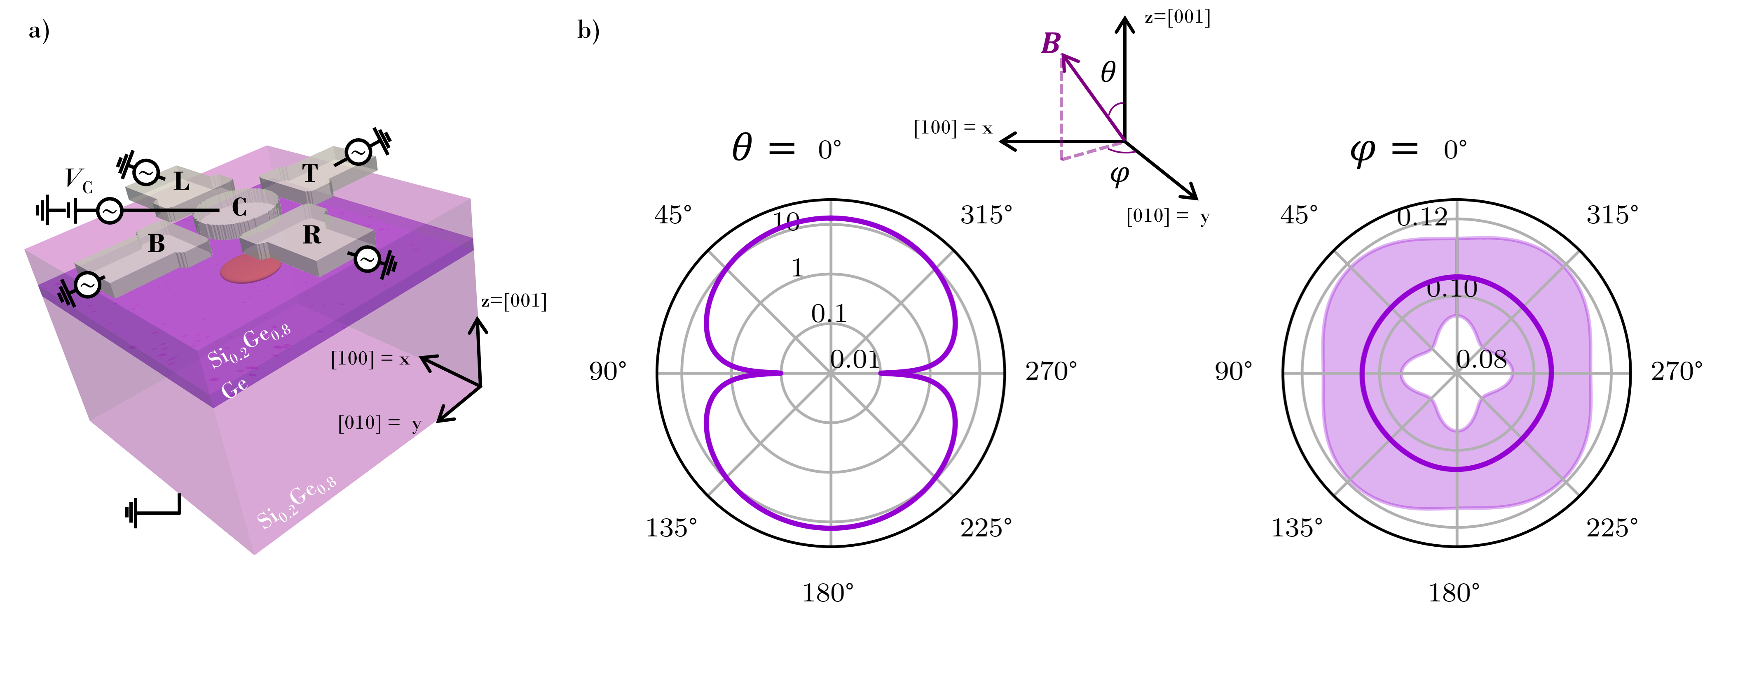
Figure 1, Variability of the effective g-factor due to a charge trap density of 10¹¹ cm⁻² at the top SiGe/oxide interface. a) Simulated device. b) Magnetic field dependence of the average g-factor for 1.000 independent devices in presence of disorder. Pink shaded area highlights variability as the average plus (minus) the standard deviation of the effective g-factor.
[1] Phys. Rev. Applied 17, 024022 (2022).
[2] Phys. Rev. B 106, 235426 (2022).
[3] Phys. Rev. Lett. 131, 097002 (2023).
[4] Phys. Rev. B 108, 205416 (2023).
[5] Manuscript in preparation.
[5] Phys. Rev. Applied 22, 024030 (2024).
[6] arXiv:2407.19854 (2024).

