Quantum simulation with triangular triple quantum dots
Tsung-Lin Chung¹, Oswin Krause², Anasua Chatterjee³, Ferdinand Kuemmeth¹
¹Center for Quantum Devices, Niels Bohr Institute,
University of Copenhagen, 2100 Copenhagen, Denmark
²Department of Computer Science,
University of Copenhagen, 2100 Copenhagen, Denmark
³QuTech and Kavli Institute of Nanoscience,
Delft University of Technology, 2600 GA Delft, The Netherlands

Analog quantum simulation provides a direct way to explore physics phenomena which are computationally complex for classical computers. Well-controlled quantum devices can serve as analog quantum simulators. With the operation of these highly tuneable quantum systems, one can engineer Hamiltonians to provide insight into nontrivial physical properties. Gate-defined quantum dot systems are an attractive platform for Fermi-Hubbard model simulations. Recent works have demonstrated the analog quantum simulation of Mott-insulator transitions [1], Nagaoka ferromagnetism [2], Heisenberg spin chains [3], and exciton formation [4].
In our work, we develop a triangular triple quantum dot system as a quantum simulator (Fig. 1). Depending on the carrier numbers on each site, the interacting fermions are expected to form interesting phases, including spin-frustrated magnetism and high-spin ground states that are absent in linear triple dots. Proximal charge sensors near the triple dot provide correlated information on carrier dynamics within array, which we explore as a means of precisely tuning the energy levels within the array. We hope to also use these time-domain signals to study spin dynamics and the emergence of magnetism and electron-electron interaction effects.

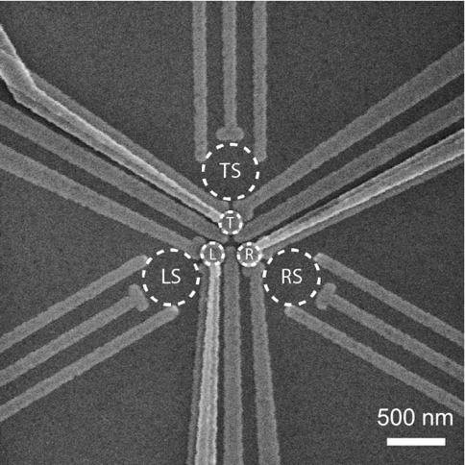
Figure 1, SEM image of the triangular triple quantum dot simulator. The dashed white circles indicate the triangular triple quantum dots at the center and the three charge sensors nearby.

[1] T. H et al. Nature 548, 70 (2017)
[2] J. P. Dehollain et al. Nature 579, 528 (2020)
[3] C. J. Dipen and T.-K. Hsiao et al. Phys. Rev. X 11, 041025 (2021)
[4] T.-K. Hsiao and P. Cova Fariña et al. Phys. Rev. X 14, 011048 (2024)

