Autotuning multiple quantum dots in the slow tunnelling regime
Chanung Park¹, Kyunghoon Jung^{1,2}, Dohun Kim¹
¹Department of Physics and Astronomy, Institute of Applied Physics, Seoul National University, Seoul, Republic of Korea
²Zurich Instruments AG, CH-8005 Zurich, Switzerland

Gate-defined semiconductor quantum dots (QDs) provide a prominent platform for quantum computation due to their compatibility of modern microfabrication technology and competitive coherence. However, the complexity of tuning various device parameters increases with the number of QDs. Automated tuning methods based on machine learning have been proposed to tackle this task, with some successful results, but mostly considering single or double QDs so far [1-6]. In this presentation, we consider charge state autotuning of three or more QDs. In the slow tunnelling regime, “latching” makes tuning difficult, which is common in QDs that are not directly coupled to the electron reservoir. We incorporate latching phenomenon in simulating QDs stability diagram to efficiently generate realistic training data. We discuss the utility, current limitation, and path for improvement of reinforcement learning (RL) to auto-tune multiple QDs.
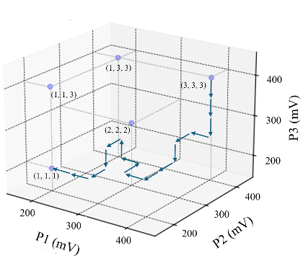
Figure 1, The RL agent’s trajectory that starts with the initial state, a blue triangle: (3, 3, 3) charge state, and reaches the goal state, a red star: (1, 1, 1) charge state. The trajectory is highly optimized and direct, demonstrating the agent’s advanced capability to navigate the state space efficiently.

[1] Durrer R. et al. Phys. Rev. Appl. 13, 054019 (2020)
[2] Kalantre S. S. et al. npj Quantum Inf 5, 6 (2019)
[3] Zwolak, J. P. et al. Phys. Rev. Appl. 13, 034075 (2020)
[4] Zwolak, J. P. et al. PRX Quantum 2, 020335 (2021)
[5] Schuff, J. et al. arXiv :2402.03931 (2024)
[6] Zubchenko, A. et al. arXiv :2407.20061 (2024)

