Tunable Spin-Orbit Coupling in Ge Light-Hole Quantum Channels
Patrick Del Vecchio¹, Stefano Bosco², Daniel Loss³, Oussama Moutanabbir¹
¹Department of Engineering Physics, École Polytechnique de Montréal, Montréal, Québec, Canada
²QuTech and Kavli Institute of Nanoscience, Delft University of Technology, Delft, Netherlands
³Department of Physics, University of Basel, Klingelbergstrasse 82, 4056 Basel, Switzerland

Holes in gate-defined planar germanium (Ge) quantum dots are promising candidates for reliable and scalable solid-state quantum computing. Indeed, besides its compatibility with silicon processing, Ge has gained attention due the availability of nuclear spin-free isotopes [1], which enables long qubit coherence times. Moreover, the large intrinsic spin-orbit coupling (SOC) provided by Ge-based heterostructures and the hole wavefunction symmetry pave the way to implement fast all-electrical manipulation schemes. In addition, the ability to control light-hole (LH) ground states in tensile strained Ge quantum wells was shown to be associated with large Rashba SOCs, as well as a large g-tensor anisotropy and large in-plane g-factor components [2,3]. Herein, we show that LH spins in tensile strained Ge gate-defined quantum channels and elongated quantum dots are characterized by large in-plane g-factors and tunable Rashba SOC. Furthermore, Rashba SOC strength was found to vanish at certain finite gate electric fields, which in turn strongly influences the Rabi frequency of the LH ground state. This could potentially allow operation regimes that either enhance coherence times or accelerate manipulation rates.

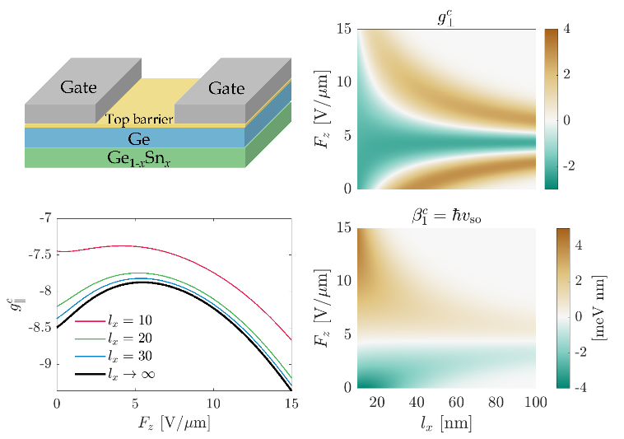
Figure 1, Schematic of the quantum channel device, out-of-plane g-factor g⟂, in-plane g-factor g∥ and linear-in-k Rashba SOC parameter

[1] O. Moutanabbir al. Advanced Materials 36, 2305703 (2024).
[2] P. Del Vecchio et al. Physical Review B 110, 045409 (2024).
[3] P. Del Vecchio et al. Physical Review B 107, L161406 (2023.)

