Long-range spin correlation in spin wave modes prepared in gate-defined quantum dot arrays
Tien-Ho Chang¹, Chia-Hao Wei¹, Kim Chye Cheng¹, Jian-Chang Zeng¹, Fu-Yuan Gu¹,
Ruei-Syuan Chiang¹, Yin-Chuan Lai¹, Jun-Yang Yuan¹, Chi-Wei Lee¹, Jo-Yu Wang¹
and Tzu-Kan Hsiao^{1,2}
¹Department of Physics, National Tsing Hua University, Hsinchu 300044, Taiwan
²Center for Quantum Science and Technology, National Tsing Hua University, Hsinchu 300044, Taiwan

Spins in gate-defined quantum dot arrays are a naturally candidate for studying quantum magnetism in Heisenberg model. In particular, the development of initialization, control and readout techniques has facilitated realizations of Nagaoka ferromagnetism, Heisenberg antiferromagnetic spin chains, and resonating valence bond states. Nevertheless, the observation of long-range spin order in magnetic phases remains elusive in quantum dot systems.
Here we report our progress in studying quantized spin wave states in a quantum dot ring. We will describe experimental methods for preparing and probing the spin waves in an intermediate-scale quantum dot array. The long-range spin order can be confirmed by measuring the spin correlation as a function of distance. From the spin correlation we can further obtain the spin structure factor and the spin wave dispersion relation. Finally, we will show our measurement progress for this project.
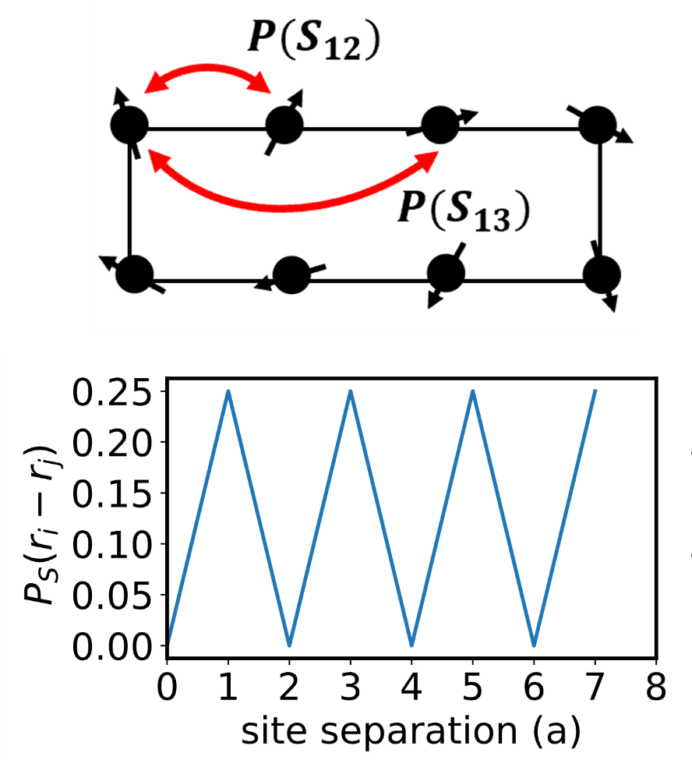
Figure 1, Singlet projection probability as a function of site separation.

