Strong hole-photon coupling in planar Ge: probing the charge degree and Wigner molecule states
Franco De Palma^{1,2†}, Fabian Oppliger^{1,2†}, Wonjin Jang^{1,2†}, Stefano Bosco³, Marian Janik⁴, Stefano Calcaterra⁵, Georgios Katsaros⁴, Giovanni Isella⁵, Daniel Loss⁶, Pasquale Scarlino^{1,2}

¹Hybrid Quantum Circuit Laboratory, Institute of Physics, École polytechnique fédérale de Lausanne (EPFL), Lausanne, 1015, Switzerland
²Center for Quantum Science and Engineering, École polytechnique fédérale de Lausanne (EPFL), Lausanne, 1015, Switzerland
³QuTech and Kavli Institute of Nanoscience, Delft University of Technology, Delft,The Netherlands
⁴Institute of Science and Technology Austria, Am Campus 1, Klosterneuburg, 3400, Austria
⁵L-NESS, Physics Department, Politechnico di Milano, via Anzani 42, Como, 22100, Italy
⁶Department of Physics, University of Basel, Klingelbergstrasse 82, Basel, 4056, Switzerland
†These authors contributed equally to this work

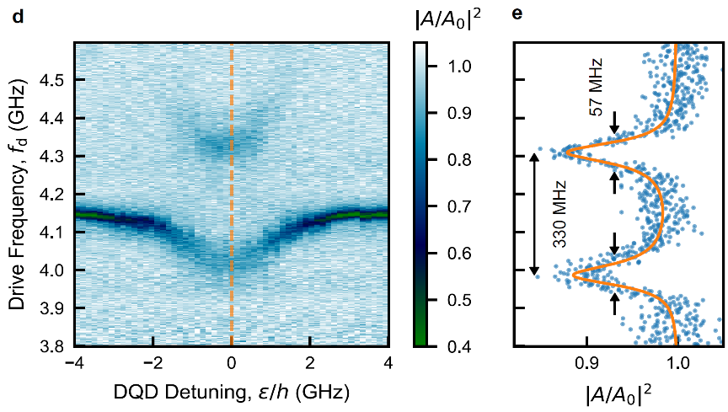
Semiconductor quantum dot (QD) qubits represent one of the promising candidates for future quantum information processing architectures. In terms of scalability of QD qubits, superconductor – semiconductor hybrid circuits may facilitate the scaling of QD qubits to a practical limit. QDs embedded in a superconducting cavity can interact with the microwave photons residing in the cavity, where these photons can allow, for example, long-range interaction between distant QD qubits, and high-fidelity quantum state detections. Recent works have demonstrated that hole QD qubits can offer a favorable route toward large scale quantum computation based on its intrinsic spin-orbit interaction and p-type wavefunction. In the aspect of material for hole QD definition, Ge/SiGe heterostructures provide 2-dimensional hole gas with high mobility and small effective mass which allows scalable QD architectures. However, coherent interaction between a photon and a hole QD in Ge/SiGe heterostructures have not been investigated in detail up to date. Here, we investigate the strong photon coupling to hole charge qubits defined in Ge/SiGe heterostructure. By coupling a tunable, high-impedance superconducting quantum interference device (SQUID) array cavity to a double QD (DQD), we observe a vacuum-Rabi splitting of the resonator mode with a cooperativity C ~ 100 confirming the strong coupling regime. Our tunable SQUID array cavity is exploited to perform spectroscopy of the DQD charge qubits, and to further study quenched energy spectrum of Wigner molecule states. We further find that the Wigner molecule states are less susceptible to charge noise due to distinct spin structure, which provides a route toward coherent spin-photon interface based on exchange interaction in a DQD.
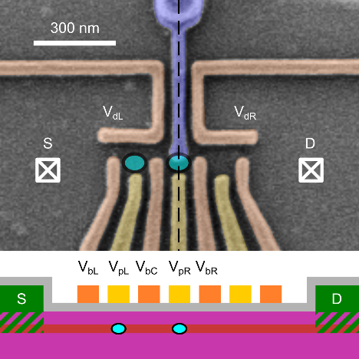

[1] De Palma, F., Oppliger, F., Jang, W. et al. arXiv:2310.20661v1 [quant-ph] (2023).

