Singlet-triplet and exchange-only

flopping-mode spin qubits
Simon Stastny and Guido Burkard
Department of Physics, University of Konstanz, Germany

Electron or hole spins in quantum dots coupled to a microwave cavity are an established platform to realize qubits. In the first part of this work, we combine the $ST_{0}$ qubit [1,2] with the versatile flopping-mode qubit [3,4] to achieve a tunable coupling. We therefore introduce a spin qubit consisting of two electrons in three quantum dots in a magnetic field gradient. Tunnel couplings between the dots allow for an orbital degree of freedom. The system operates in the $ST_{0}$ regime near the $|1,0,1⟩↔|0,1,1⟩$ charge transition. We calculate the effective transversal and longitudinal spin-photon couplings in this regime and investigate them by observing the cavity transmission near the qubit resonance. In the second part of this work these calculations are extended to the exchange-only qubit which comprises four dots with three electrons.
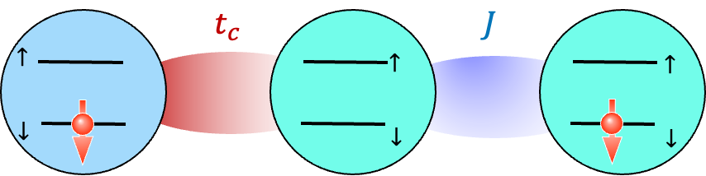

Figure 1, The singlet-triplet flopping-mode spin qubit. The two electrons can tunnel between three electrically tunable quantum dots. In the operating regime, the right dot is always occupied, so the tunnel coupling t_{c} couples the two effective charge states |1,0,1⟩ and |0,1,1⟩. The tunnel coupling between the center and right dots contributes to the exchange interaction parameter J. Magnetic fields in the z-direction with site dependent magnitude at each dot lead to Zeeman splitting, separating the polarized triplets from the $ST_{0}$ operating regime.

[1] J. R. Petta et al., Science 309,2180 (2005)
[2] J. Levy, Phys. Rev. Lett. 89, 147902 (2002)
[3] M. Benito, J. R. Petta, and G. Burkard, Phys. Rev. B 100, 081412 (2019)
[4] X. Croot et al., Phys. Rev. Res. 2, 012006 (2020)

