Improvements towards hermetic packaging of levitating qubit devices
P. Russell^{1,2}, K.L. Matkovic ¹, A. Palmer¹, L. Delventhal¹, M.C. Cassidy¹
¹School of Physics, University of New South Wales
²School of Electrical Engineering, University of New South Wales

The advancement of levitating qubit devices presents a breakthrough in quantum computing [1]. Levitating electrons on noble gases allows the qubit to reside in vacuum, physically isolating itself from impurities and noise [2]. When combined with circuit quantum electrodynamics architecture, these platforms promise long coherence times and fast operation times, in a highly scalable manner [3]. Hermetic packaging plays a crucial role for these devices to maintain vacuum integrity. This allows us to encapsulate the noble gas [4] to allow for the isolation of qubits from environmental interactions.
Current setups are rudimentary and involve unreliable sealing methods, leaving large gaps for improvement. Figure 1 displays an example, where a seal must be made for each RF line and may leak either through the connector itself or the seal. As the number of control lines increases, the probability of having a hermetic cell rapidly diminishes.
We offer a more robust solution, which is more efficient to setup, and more scalable than existing packages. By using high density interconnects, and a multi-layer PCB, we greatly reduce the amount of indium seals required for ultra-high vacuum and minimize the footprint of the package.
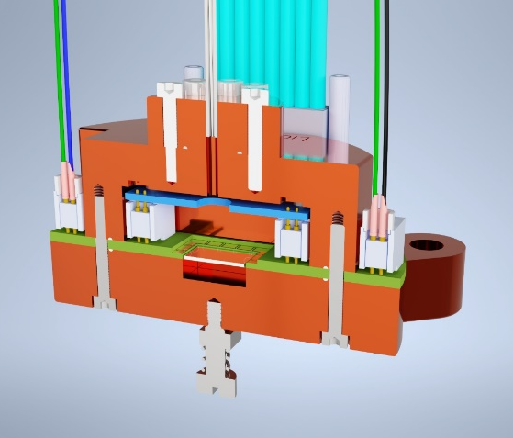
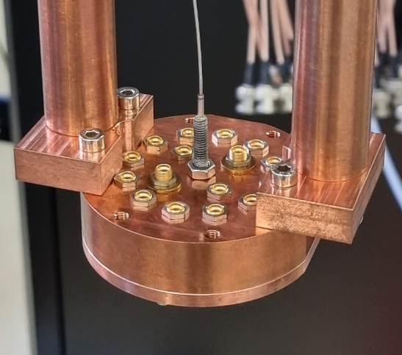
Figure 2, Full section view of presented chip holder design.
Figure 1, Hermetic cell design taken from [3].

References
[1] A. Jennings, X. Zhou, I. Grytsenko, E. Kawakami; Quantum computing using floating electrons on cryogenic substrates: Potential and challenges. Appl. Phys. Lett. 18 March 2024; 124 (12): 120501. https://doi.org/10.1063/5.0179700
[2] Koolstra, G. et al. Trapping a single electron on superfluid helium using a superconducting resonator. Ph.D. thesis, The University of New Chicago (2019)
[3] Zhou, X., Koolstra, G., Zhang, X. et al. Single electrons on solid neon as a solid-state qubit platform. Nature 605, 46–50 (2022)
[4] Yang, G. Circuit Quantum Electrodynamics with electrons on helium. Ph.D. thesis, The University of New Chicago (2020).

