Proposal of Quantum Circuit Compiler
Considering Qubit Connectivity and Addressability
with Cross-Device Architecture Evaluation
Masahiro Tadokoro^{1,2,*}, Ryutaro Matsuoka¹, Tetsuo Kodera¹
¹Tokyo Institute of Technology, Tokyo, Japan
²Mizuho-DL Financial technology Co., Ltd., Tokyo, Japan
*E-mail: tadokoro.m.aa@m.titech.ac.jp

Various device architectures with large arrays of semiconductor spin qubits have been proposed[1,2]. However, there has been no quantum algorithm compiler so far that can be used in a unified manner for different semiconductor spin qubit device architectures in order to evaluate the efficiency of quantum algorithm implementation.
In this study, we propose a quantum circuit compiler QOOCAI: Qubit Operation Orchestrator considering qubit Connectivity and Addressability Implementation, which can compile quantum algorithms to various semiconductor spin qubit device architectures with different qubit connectivity and addressability. Qubit connectivity and addressability are important features of device architectures that affect the efficiency of quantum algorithm implementation. Device architectures with various qubit connectivity and addressability are expected in semiconductor spin qubit systems[1-3], so that it is important for quantum algorithm compilers to adapt to wide range of device architectures.
In addition, we evaluate the efficiency of quantum algorithm implementation across multiple device architectures by compiling various quantum algorithms using QOOCAI and discuss the device architectures required for future large-scale quantum algorithm implementations.
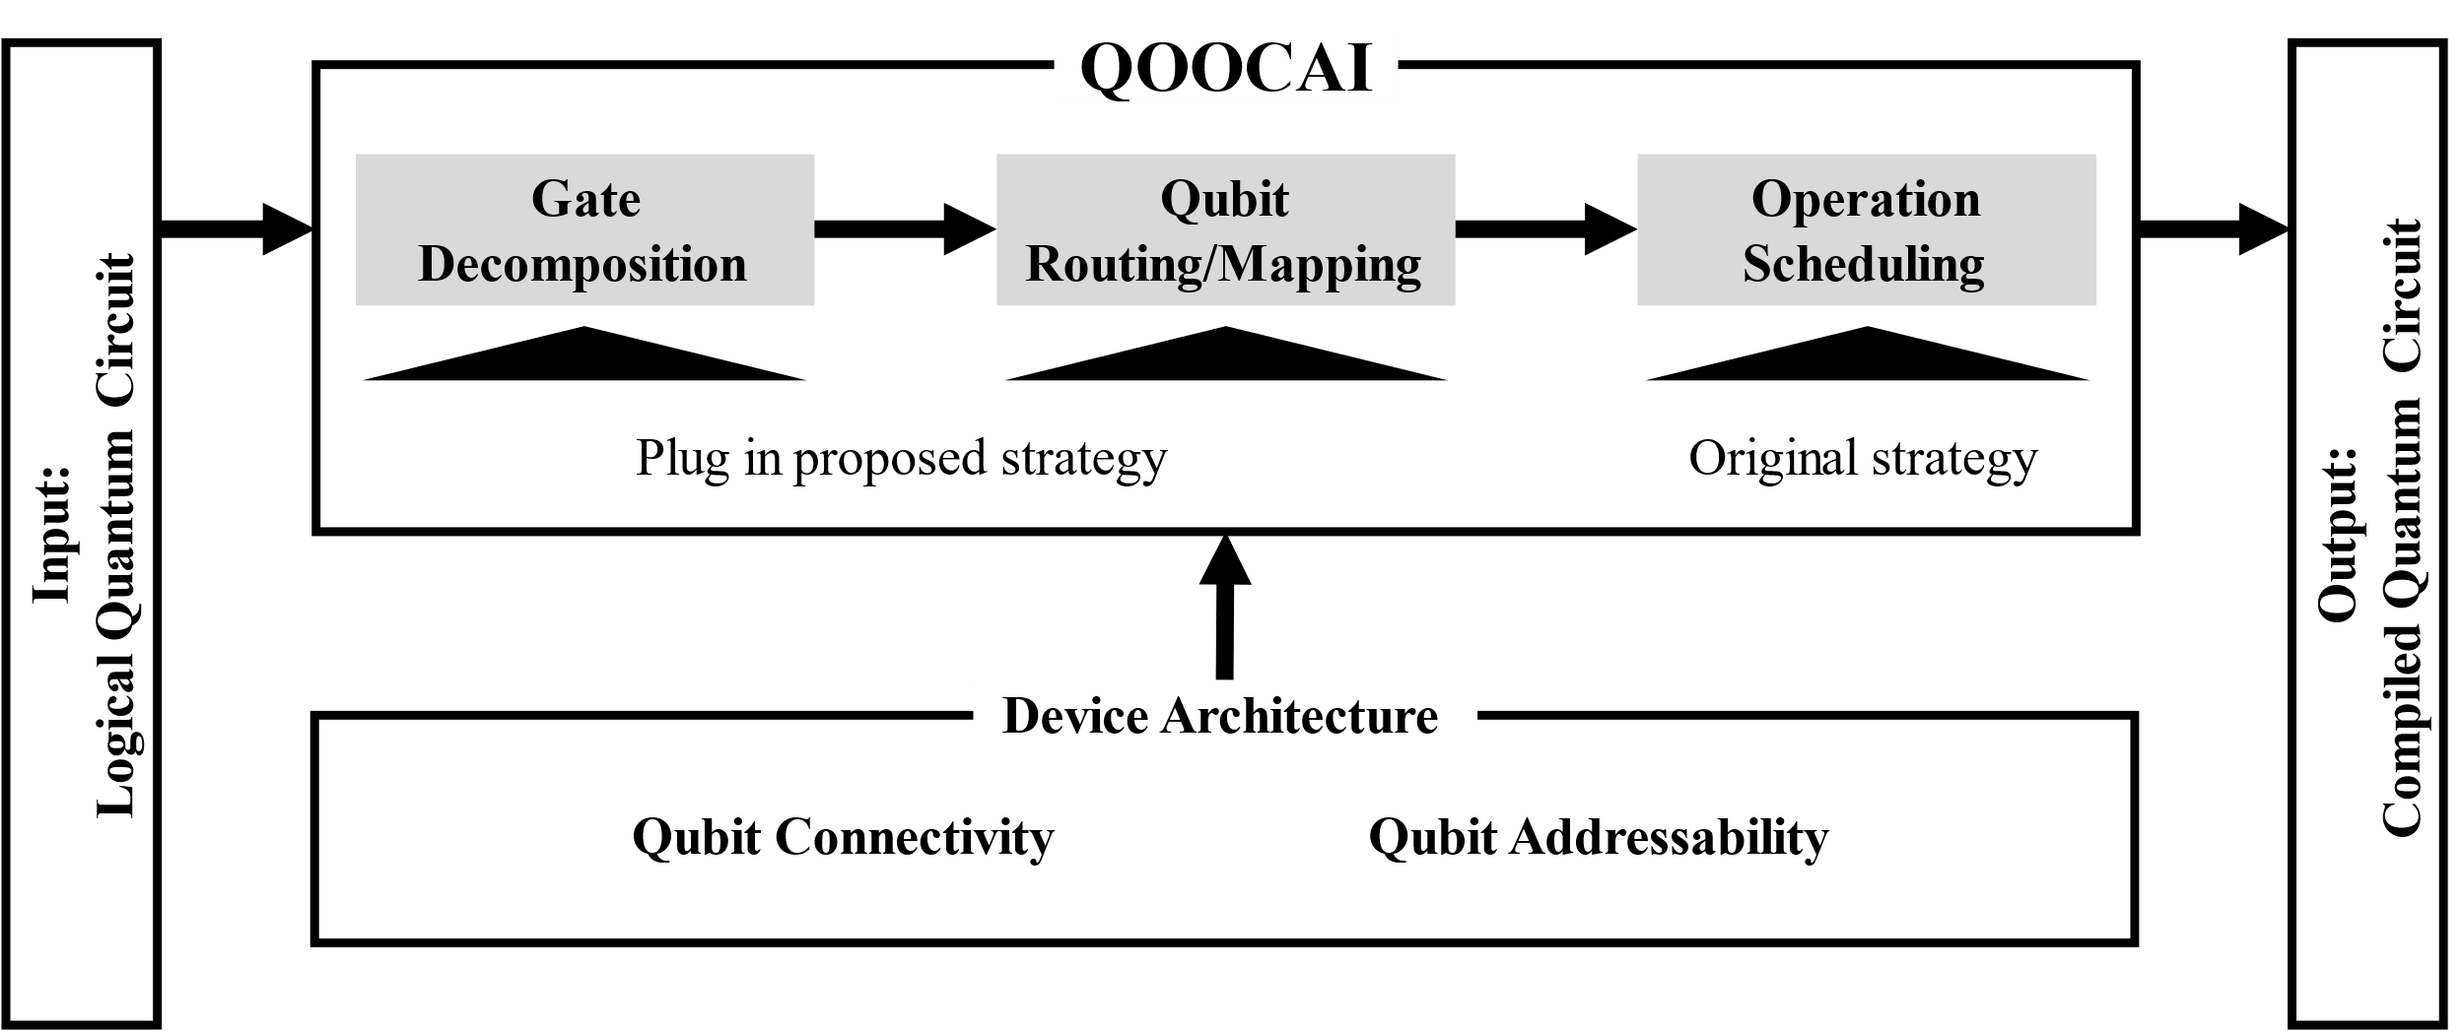
Figure 1, Overview of QOOCAI

This work was supported financially by JST Moonshot R&D Grant Number JPMJMS2065, MEXT Quantum Leap Flagship Program (MEXT QLEAP) Grant Number JPMXS0118069228, and JSPS KAKENHI Grant Numbers JP23H05455, and JP23K17327.

[1] M. Veldhorst et al. Nat. Commun. 8, 1776 (2017).
[2] M. Tadokoro et al. Sci. Rep. 11, 1 (2021).
[3] M. Tadokoro et al. Jpn. J. Appl.Phys. 59, SGGI01 (2020).

