Magnetic characterization and integration of a micromagnet in a carbon nanotube spin qubit architecture
S .Lopes ^{1,2}, M. Hehn¹, D. Lacour ¹, F. Montaigne¹, C12 team² , M. M. Desjardins²
¹ Université de Lorraine, Institut Jean Lamour, UMR CNRS 7198, Nancy 54011, France
² C12 Quantum Electronics, Paris, France

Spin qubits in semiconductor quantum dots represent a promising approach for quantum computing. At C12, we focus on electron spins confined within a double quantum dot and coupled to a microwave resonator. Recent advancements [1] have demonstrated coherent interaction via a microwave resonator between two distant semiconductor spin qubits with a fidelity of 83%. To enhance this fidelity, the outlooks are to minimize decoherence and to increase the coupling of the spin qubit to the cavity. Our work centers on developing an architecture that addresses these challenges.
By forming the dots in a suspended carbon nanotube, the coupling of the electron to the environment can be reduced. We obtain a quantum state coupled to a microwave cavity with coherence times exceeding one microsecond (see related poster).
For electrical control of the electron spin, we focus on optimizing the artificial spin-orbit coupling through the use of a micro-magnet. Based on numerical simulations [2], we determine the optimal shape of the magnet accounting for finite thickness and uniform magnetization constraints. Combining thin-film magnetic characterization and localized measurements of the stray field with a NV center microscope on patterned micro-magnet, we successfully aligned our experimental findings with micromagnetic simulations. According to our predictions, the antisymmetric stray field on each dot is expected to reach ±75 mT.
The resulting micromagnet design is integrated in a spin-qubit architecture composed of a magnetic field resilient high-impedance resonator [3] to achieve strong coupling between a spin qubit hosted in a carbon nanotube and the microwave resonator. With a kinetic inductance of 740 pH/square, the resonator, made of niobium nitride, is expected to achieve an impedance close to 1.5 kΩ.
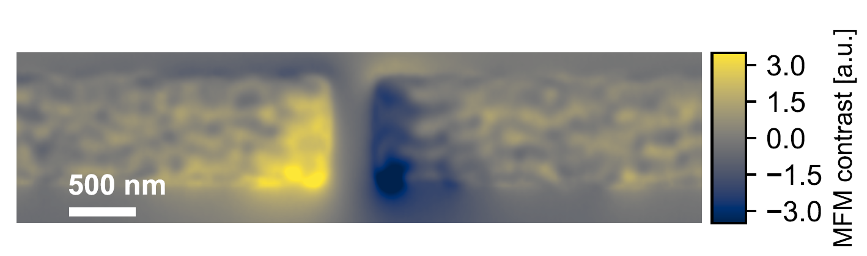
Magnet
DC electrodes
High-impedance cavity
10 µm
Cobalt
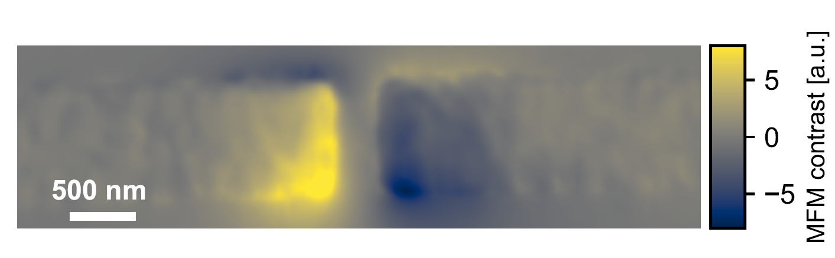
CoFe
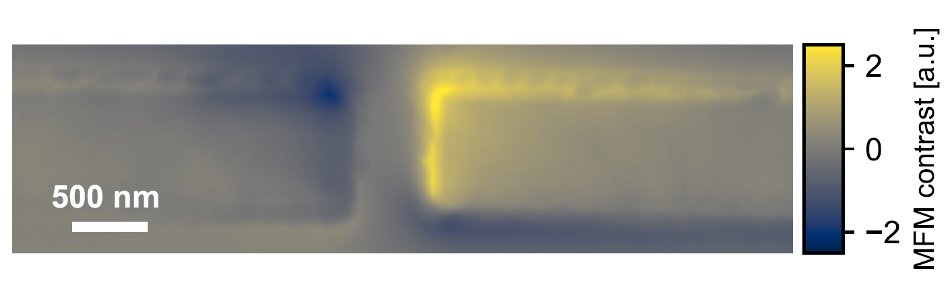
Co/Ta multilayer

Figure 2 : Scanning electron microscope image of the spin qubit architecture.

Figure 1 : Magnetic force microscopy images of micromagnets for different magnetic material.

[1] J. Dijkema, Two-qubit logic between distant spins in silicon (2023)
[2] W. Legrand et al., Optimal design of nanomagnets for on-chip field gradients (2023)
[3] C. Yu et al., Magnetic field resilient high kinetic inductance superconducting niobium nitride coplanar waveguide resonators (2021)

