Universal control and benchmarking of four singlet-triplet qubits
Elizaveta Morozova^{1, 2}, Xin Zhang^{1, 2}, Maximilian Rimbach-Russ^{1, 2}, Daniel Jirovec^{1, 2}, Tzu-Kan Hsiao^{1, 2}, Pablo Cova Fari$\tilde{n}$a^{1, 2}, Chien-An Wang^{1, 2}, Stefan D. Oosterhout^{1, 3}, Amir Sammak^{1, 3}, Giordano Scappucci^{1, 2}, Menno Veldhorst^{1, 2}, and Lieven M. K. Vandersypen^{1, 2}
¹QuTech, Delft University of Technology, Delft, The Netherlands
²Kavli Institute of Nanoscience, Delft University of Technology, Delft, The Netherlands
³Netherlands Organisation for Applied Scientific Research (TNO), Delft, The Netherlands

Semiconductor quantum dots have shown great promise for fault-tolerant digital quantum computation and analog quantum simulations. Significant progress has been made with individual spin qubits in both silicon [1] and germanium [2] in terms of scaling and performance. However, controlling large-scale arrays of individual spins presents multiple challenges, such as microwave heating and crosstalk. Unlike single-spin qubits, singlet-triplet qubits naturally align with the spin-readout basis in Pauli spin blockade and enable full electrical control using baseband voltages.
In this work, we investigate a 2x4 quantum dot ladder in Ge/SiGe, with controllable interactions between all neighboring spins, where we form four singlet-triplet qubits along the rungs of the ladder (Fig. 1 a). We demonstrate individual initialization, control, and readout of all qubits. We implement single-qubit gates along two axes of the Bloch sphere with average gate fidelities in the range of 99.49(8)-99.84(1)% obtained from randomized benchmarking (Fig. 1 b), and gate set tomography fidelities of 98.97(9)-99.61(5)%. Leveraging exchange interactions between qubits, we demonstrate a two-qubit SWAP-like gate with Bell-state fidelity of 73(1)-90(1)% and corresponding concurrences between 21(4)% and 64(4)% (Fig. 1 c). To further illustrate the remarkable level of control in the system, we create and distribute an entangled state across the array with remote Bell state fidelity of 75(2)% and concurrence of 22(4)%.
This work puts germanium singlet-triplet qubits firmly on the map as a potential platform for quantum computing.
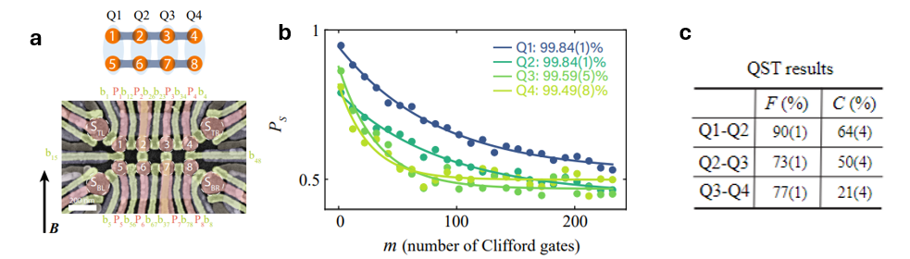
Figure 1. a) A device scheme. b) Randomized benchmarking results for single-qubit gates, yielding average gate fidelity. c) Bell-state tomography fidelities for two-qubit gates and corresponding concurrences.
[1] Philips, S. G. et al. Universal control of a six-qubit quantum processor in silicon. Nature 609, 919–924 (2022).
[2] Wang C.-A. et al. Operating semiconductor quantum processors with hopping spins. arXiv:2402.18382 (2024).

