Spin qubits in carbon nanotubes : a platform for quantum computing
F.N. Krauth¹, B. Neukelmance¹, M. Hynes¹, B. Hue^{1,2}, A . Larrouy¹, L. Godet¹, L. Vistoli¹, T. Kontos², M. Delbecq², M.M. Desjardins¹
¹C12 Quantum Electronics, Paris, France
²Laboratoire de Physique de l’École normale supérieure, ENS, Université PSL, CNRS, Sorbonne Université, Université Paris Cité, Paris, France

Spin qubits in semiconductor quantum dots represent a promising platform for quantum computation. The platform builds on the formidable technological maturity of the classical semiconductor industry, the qubits are compact and have demonstrated fault-tolerant single and two-qubit gate operations^{[1].} In the last few years, the effort towards reaching sub-threshold operation fidelities has been hampered by electric-field noise induced by charge fluctuators in the environment^{[2]}. To pave the way towards large and useful quantum processors, a second effort of the spin qubit community has been to couple distant spin qubits via superconducting resonators.
We propose to tackle these two challenges using carbon nanotubes as the host semiconducting structure. By suspending the carbon nanotube, the quantum dots hosting the spin qubits can be moved away from potential charge fluctuators. Based on recent measurements, we show that we can reproducibly create and control long-lived quantum states in such structures, while being coupled to a superconducting cavity used for state-readout. We demonstrate relaxation times near ten micro-seconds, and coherence times above one micro-second without any particular optimization. The particularities of the observed time-dynamics are attributed to the valley degree of freedom. Finally, we introduce ongoing efforts towards engineering cavity-mediated two-qubit coupling based on high-impedance superconducting resonators (see poster by S. Lopes).
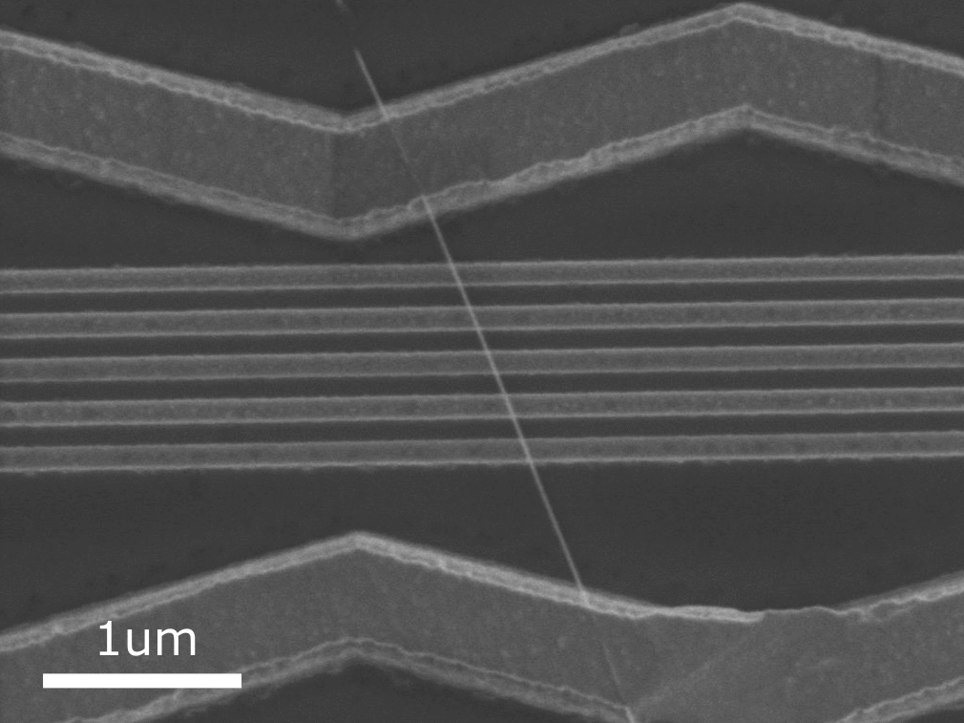
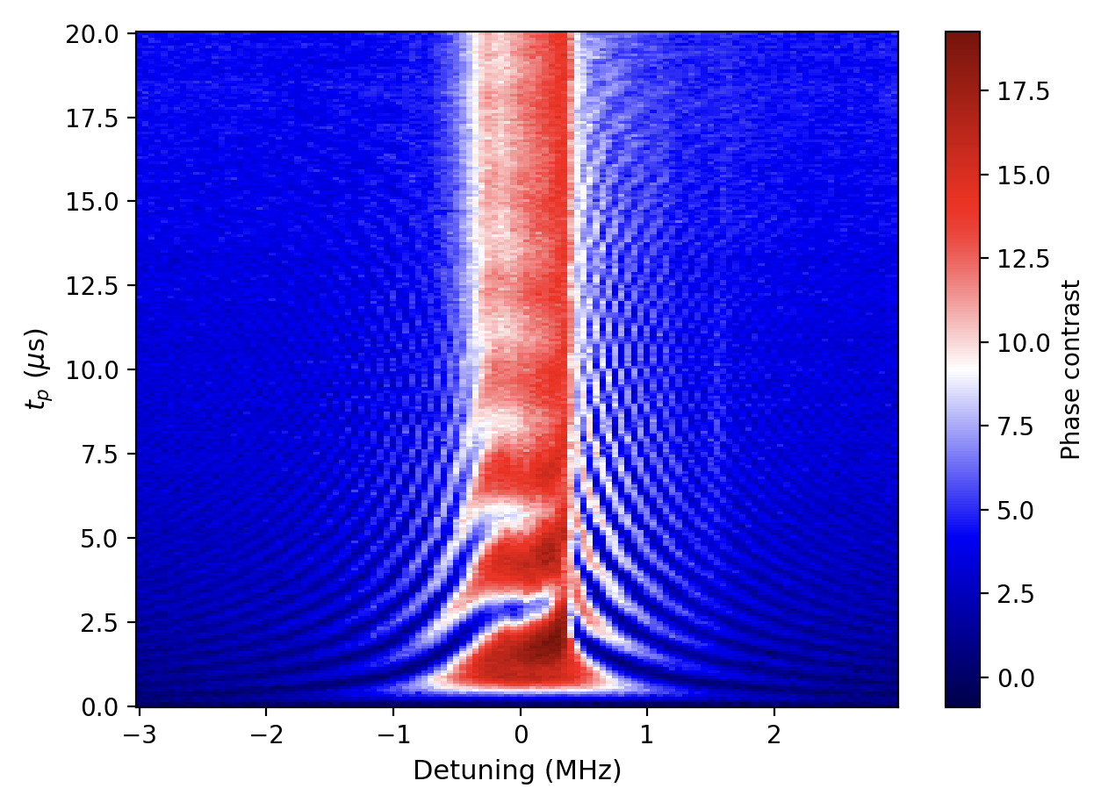

Figure 1: SEM image of a typical device, with the suspended nanotube in the middle, 5 horizontal metallic gates, and a source and drain contacts on top and bottom.

Figure 2: Rabi chevron with T₂^{R}=10.5us, on a transition with T₁=8.7us and T₂*=1.5us.

[1] Ma̧dzik et al. Nat Commun 12, 181 (2021)
[2] Yoneda et al. Nature Nanotech 13, 102–106 (2018).

