Ultrafast electrical switching and charge state control of silicon vacancy centers in diamond
M. Rieger¹, V. Villafañe², L. Todenhagen¹, S. Appel², R. Poudel¹, T. Waldmann¹, M. Brandt¹, J. J. Finley¹, K. Müller²
¹Walter Schottky Institute, School of Natural Sciences and MCQST,
Technical University of Munich, 85748 Garching, Germany
²Walter Schottky Institute, School of Computation, Information and Technology and MCQST,
Technical University of Munich, 85748 Garching, Germany

Optically active point defects in diamond feature atomic-sized two-level systems, constituting a promising solid-state platform for spin-photon interfaces for quantum technologies. Specifically, group IV vacancy complexes in diamond (G4V) (with silicon, germanium, tin or lead) show excellent optical properties due to their crystallographic symmetry which favors emission into ZPL. In this group, the silicon vacancy (SiV⁻) has been so far the most studied complex and T₂ spin coherence times exceeding ~10ms have been demonstrated at low operation temperatures (T~100mK).
In this contribution, we present our recent results on controlling and understanding the SiV⁻ charge state mechanisms towards implementing spin-to-charge conversion protocols¹. In addition, we demonstrate the stabilization of the SiV⁻ charge state under resonant driving².
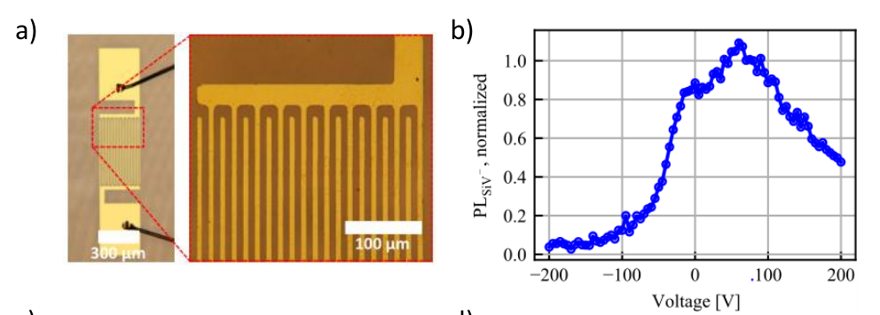
Fig. 1. a) Optical micrograph of the diamond in planar-interdigital configuration. b) SiV- photoluminescence intensity upon changes in the applied voltage between V=±200 V.

Utilizing interdigitated metallic contacts on the diamond surface, we are able to manipulate the charge state of SiV⁻ centers and demonstrate that they can be switched reversibly between SiV⁰ and SiV⁻ at MHz-rates (see Fig. 1). We furthermore fully explore the charge cycle of the SiV⁻ center spectroscopically and find that it is aided by the presence of P1 and divacancy centers in the host lattice. Our results shed light on the charge cycle mechanisms on G4V and elucidate the potential for realizing an opto-electronic readout of their spin state. For individual centers, we observe that the proximal biased electrode can enhance the steady state SiV⁻ luminescence after several ms of strong resonant driving by factor 4.

[1] M. Rieger et al. Sci. Adv. 10, eadl4265 (2024)
[2] M. Rieger et al. in preparation (2024)

