Quantum Hall effects in quantum point contacts in Ge
Karina Hudson¹, Davide Costa¹, Davide Degli Esposti¹, Lucas E. A. Stehouwer¹, Giordano Scappucci¹
¹QuTech and Kavli Institute of Nanoscience, Delft University of Technology, PO Box 5046, Delft, 2600 GA, The Netherlands

Quantum point contacts (QPCs) are quasi-one-dimensional constrictions that are versatile for probing properties of the underlying semiconductor heterostructure such as spin-orbit interaction[1], and properties of neighbouring nanostructures such as quantum dot charge states[2,3]. In this study, we investigate the transmission of edge states in QPCs fabricated on a low-disorder strained Ge quantum well. By applying large out-of-plane magnetic fields we observe the transition from 1D ballistic conductance to 2D quantised edge modes in two QPCs with different lithographic gate dimensions and therefore different 1D confinement profiles.
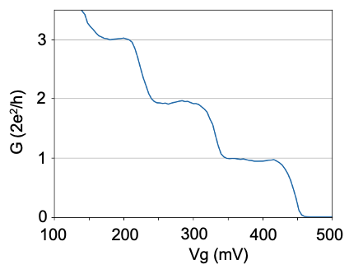
Figure 1 (a). Conductance G in integer multiples of 2e²/h as a function of split gate voltage V_{g} at B=0T showing the first three 1D subbands.
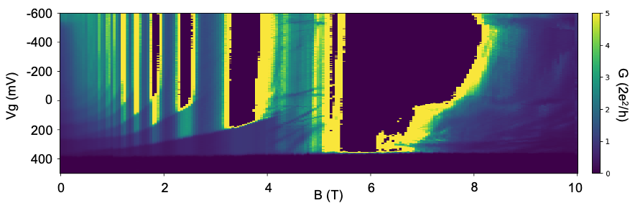
Figure 2, Colourmap of conductance plotted against Vg and out-of-plane magnetic field B.

[1] F. Nichele, et al. Phys. Rev. Lett. 113, 046801 (2014)
[2] M. Field, et al., Phys. Rev. Lett. 70, 1311 (1993)
[3] Xian Wu, et al., PNAS, 111 (33) 11938-11942 (2014)
[3] J. Nakamura, et al., Phys. Rev. Lett. 130 076205 (2023)

