Iterative improvement in the fabrication and quantum control of linear spin qubit array in ²⁸Si/SiGe
Jaemin Park¹, Hanseo Sohn¹, Hyeongu Jang¹, Younguk Song¹, Lucas E. A. Stehouwer², Davide Degli Esposti², Giordano Scappucci², Dohun Kim¹
¹Department of Physics and Astronomy, Institute of Applied Physics, Seoul National University
²QuTech and Kavli Institute of Nanoscience, Delft University of Technology

The electron spin qubit confined in silicon quantum dots has been extensively investigated due to its favorable properties for developing scalable quantum processors such as compatibility with the modern semiconductor foundry process, high degree of coherence of spin, and relatively high-temperature operations. We present a collection of iterative spin qubit development results that we performed for the last three years on a ²⁸Si/SiGe heterostructure wafer [1]. We discuss the limitation of the first design in dynamically controlling tunnel coupling and more-than-necessary decoherence gradient. To address the issue, we optimized the width of metal gates and the design of the micromagnet. In the most recent batch, by employing the Pauli Spin Blockade (PSB) based parity readout method, we achieve a high readout fidelity using a delicate pulse sequence [2]. Using the readout method and improved controllability of tunnel coupling, we implement a high-fidelity two-qubit gate between the central quantum dot and the adjacent one. We further discuss the prospects of near-term goals using the latest version devices such as the generation of three to five-qubit entanglement in the temperature range 0.01 ~ 1.5K.
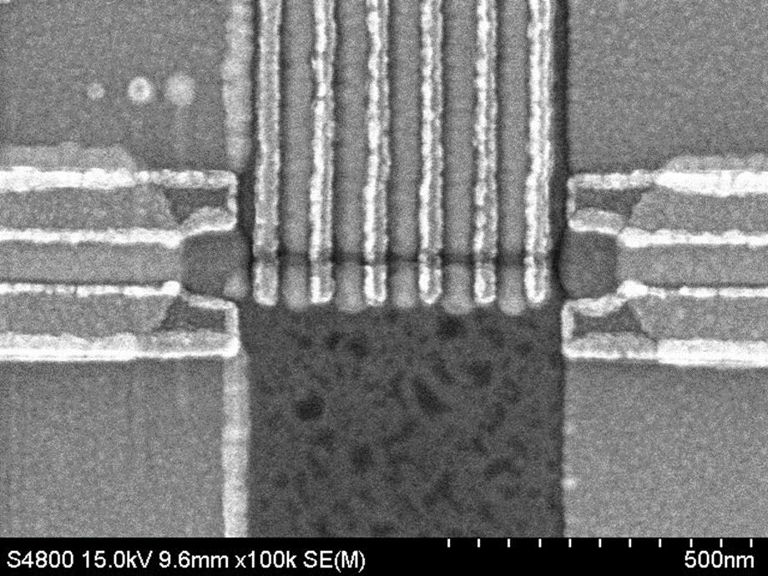
Figure 1, Scanning Electron Microscope image of the latest version of 5Q device on ²⁸Si/SiGe.
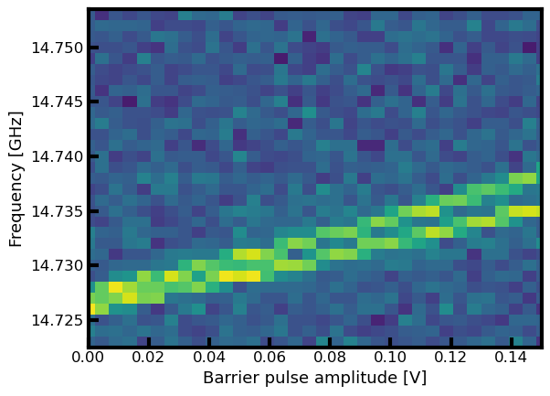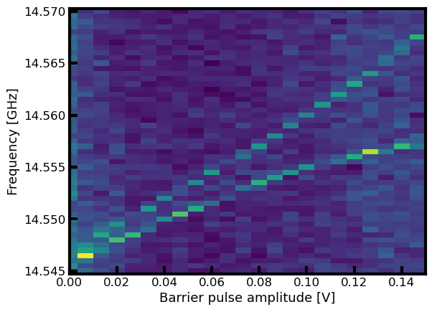
Figure 2, Comparison of two-qubit coupling controllability using barrier pulses for the 1st version (left) and the latest version (right)
[1] D. Degli Esposti et al. Applied Physics Letters 120(18) (2022)
[2] K. Takeda et al. npj quantum information 10(1) (2024)

