Electron $g$-factor of strained germanium
Katsuki Imakire¹, Akira Oiwa² and Yasuhiro Tokura¹
¹Faculty of Pure and Applied Sciences, University of Tsukuba
²SANKEN, Osaka University

One of the technical challenges for optical communication of quantum information is the realization of quantum repeaters that enable quantum information in photons to be transmitted over a long-distance using quantum entanglements and Bell measurement. For scalable realization of them, solid state quantum memories that can transduce the quantum information of photons to that of spins are indispensable^{[1]}. The Ge hole system confined in an electrostatically defined quantum dot realized in a SiGe/Ge quantum well is attracting attention as one of the candidates for quantum memory. Ge is an ideal environment for spin systems, where the effect of nuclear spins on hole spins is weak and can completely be taken away by isotope engineering. Moreover, coherent manipulation of hole spins had been demonstrated using spin-orbit interaction or $g$-tensor. However, what is important for transducing the quantum information contained in the photon polarization state to hole spin state is that the Zeeman splitting of the electrons at the $Γ$ point in the bottom of the conduction band is sufficiently larger than that of the holes at the top of valence band. This energy splitting is determined by the $g$-factor ($g$-tensor in general). Since the hole $g$-factor for the magnetic field applied normally to the plane is extremely large, we apply an in-plane magnetic field where the hole $g$-factor at the top of the valence band is reported to be 0.16~0.26^{[2]} in a Ge quantum well grown on the Si_{0.2} Ge_{0.8} substrate. The bulk $g$-factor of electrons at $Γ$ point had been known to be about -2.6 ^{[3]}. On the other hand, the $g$-factor of electrons in the conduction band in strained Ge quantum wells has not yet been reported.
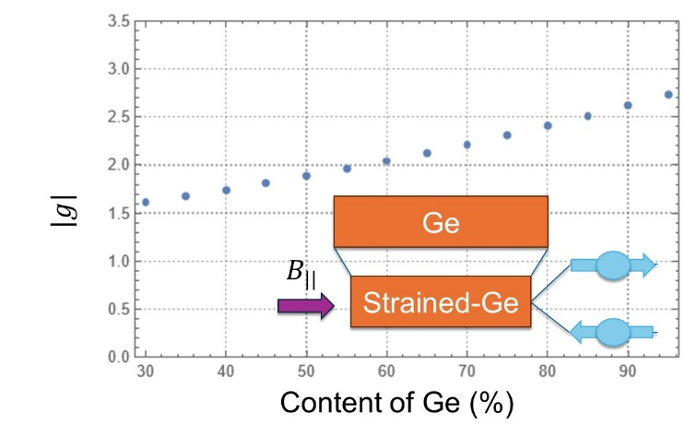
We theoretically investigated the electron $g$-factor of strained Ge in a SiGe heterostructure under an in-plane magnetic field. We assume that Ge is grown to the [001] direction and the effect of the second order in the strain is negligible. To calculate the effective $g$-factor, we focused on 8 bands, the conduction band, heavy hole, light hole, and spin-split-off bands and we used experimental parameters as deformation potentials, band gaps, and strains. We found that the absolute value of the electron $g$-factor decreases with increasing in-plane compressive strain (as shown in the inset to Fig. 1) by decreasing the content of Ge in the SiGe substrate (Fig. 1). We had confirmed that the $g$-factor of electrons at $Γ$ point is sufficiently larger than in-plane $g$-factor of holes even for strained system.
This research was supported by Grant-in-Aid for Scientific Research (S) [23H05458] from JSPS and the JST Moonshot R&D-MILLENNIA Program Grant No. JPMJMS2061
Fig. 1. Strain dependence of Ge electron $g$-factor

[1] A.Oiwa, et al. Journal of the Physical Society of Japan, 86, 011008 (2017) .
[2] N. W. Hendrickx, et al., Nature 591, 580 (2020).
[3] L. M. Roth, B. Lax and S. Zwerding, Phys. Rev. 114, 90 (1959).

