Zero-noise extrapolation-based quantum error mitigation in a silicon spin qubit
Hanseo Sohn^{1†}, Jaewon Jung^{1†}, Jaemin Park^{1†}, Hyeongyu Jang¹, Lucas E. A. Stehouwer², Gavide Degli Esposti², Giordano Scapucci², and Dohun Kim^{1*}
¹Department of Physics and Astronomy, and Institute of Applied Physics, Seoul National University, Seoul 08826, Korea
²QuTech and Kavli Institute of Nanoscience, Delft University of Technology, PO Box 5046, 2600 GA Delft, The Netherlands
†These authors contributed equally to this work
*Corresponding author: dohunkim@snu.ac.kr

As quantum computing advances, error reduction remains crucial for near-term devices. Although quantum error correction-based fault-tolerant quantum computing offers ultimate error robustness, its successful implementation requires a large number of physical qubits with low average error rates, which are not yet widely applicable. Quantum error mitigation [1] provides a more immediate and resource-efficient alternative. Here, we present the implementation of a zero-noise extrapolation-based error mitigation technique [2,3] on a silicon spin qubit platform, building on successful demonstrations in other quantum systems such as superconducting qubits, trapped-ion qubits, and photonic processors. We first study three methods for noise amplification on a silicon spin qubit: global folding, local folding, and pulse stretching, using a standard randomized benchmarking protocol. We then employ global folding-based zero-noise extrapolation to the state tomography and improve the state fidelity from the unmitigated fidelities 75.82% and 82.16% to 99.96% and 98.52%, for different preparation states $|-Y⟩$ and $|X⟩$. The results demonstrate that zero-noise extrapolation is a versatile technique applicable across quantum computing platforms, regardless of their different noise characteristics via appropriate noise amplification methods.
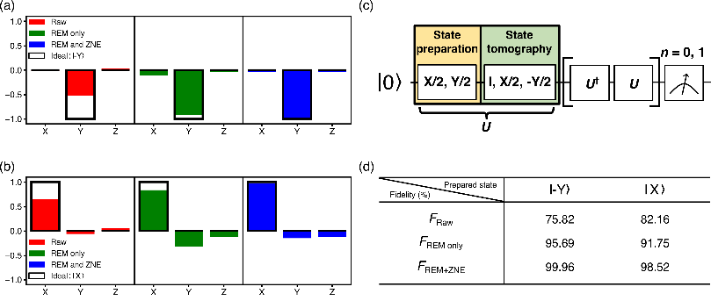
Figure 1, Quantum state tomography results for two different prepared states: (a) $|-Y⟩$ and (b) $|X⟩$. (c) A schematic of the state tomography sequence for zero-noise extrapolation. (d) State fidelities of data with unmitigated (F_{Raw}), with readout error mitigation (F_{REM only}), and with both readout error mitigation and zero-noise extrapolation (F_{REM+ZNE}).

[1] Z. Cai, R. Babbush, S. C. Benjamin, S. Endo, W. J. Huggins, Y. Li, J. R. McClean,
and T. E. O’Brien, Quantum Error Mitigation, Rev. Mod. Phys. 95, 045005 (2023).
[2] K. Temme, S. Bravyi, and J. M. Gambetta, Error Mitigation for Short-Depth
Quantum Circuits, Phys. Rev. Lett. 119, 180509 (2017).
[3] A. Kandala, K. Temme, A. D. Córcoles, A. Mezzacapo, J. M. Chow, and J. M. Gambetta, Error Mitigation Extends the Computational Reach of a Noisy Quantum Processor, Nature 567, 491 (2019)

