Material characterisation and vertical interconnects for SiGe spin qubit devices
H.G.J. Eenink¹, S.D. Oosterhout¹, L. Tryputen¹, S. Karwal¹, T.J.J. Willigers¹, F. Borsoi², V. John², R. Hanfoug¹, G. Scappucci², M. Veldhorst², L.M.K. Vandersypen², D.J. Michalak¹
1 QuTech and TNO Netherlands Organisation for Applied Scientific Research, Stieltjesweg 1 2628 CK, Delft, Netherlands
2 QuTech and Kavli Institute of Nanoscience, Delft University of Technology, Mekelweg 5 2628 CD, Delft, Netherlands
The development of semiconductor spin qubit devices [1] depends on high quality materials. Besides the semiconductor heterostructure [2], the metal and insulator of the gatestack need to be characterised in order to engineer and scale to larger quantum processing units (QPU).
We show room temperature characterisation of metal test structures integrated on the same chip as the qubit devices, and observe that processed palladium has a higher sheet resistance than as deposited (figure 1a). Additional resistance could contribute to “heating” during qubit operations [3]. Moving on to the dielectric, we measure the frequency dispersion of our atomic layer deposited Al₂O₃ (figure 1b). We believe understanding this dispersion is critical for engineering the stability, drift and charge noise of spin qubit devices.
From micromagnet simulation, design, fabrication and material optimisation, we ensure frequency addressability of our qubits.
Aided by our materials research, we are fabricating a wide range of spin qubit devices, including an 8 qubit linear array with micromagnets (figure 2a) and devices with vertical interconnects (figure 2b).
This combination of knowledge of materials and devices will be crucial in scaling up QPUs.
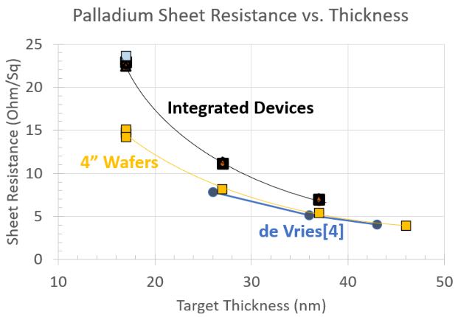 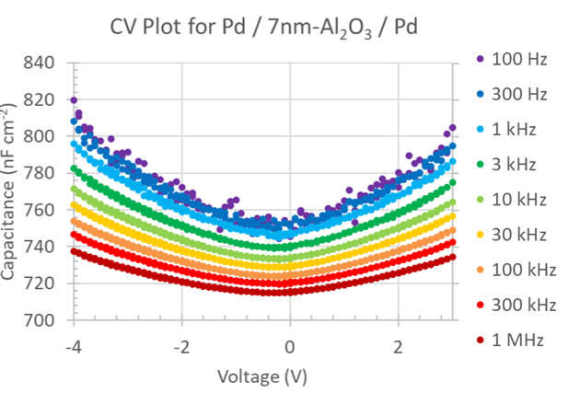
b
a
igure 1 a: Sheet resistance for integrated test structures (black and blue squares) increasing.
b: Capacitance-voltage (CV) data of the Al₂O₃ film.
a
b
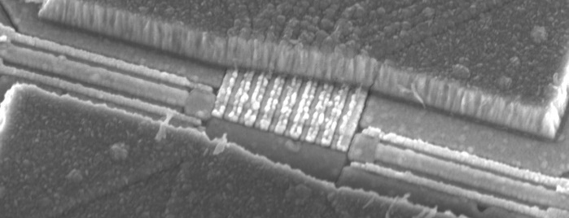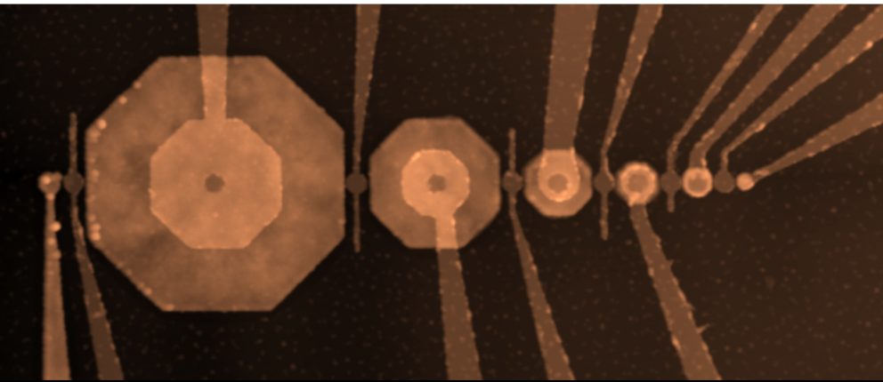
Figure 2: a: SEM image of 8 qubit linear array. b: AFM image of vertically contacted gates.
- Philips et al., Nature, 609 (2022) 919.
- Degli Esposti et al., npj quantum information 10, (2024) 32
- Undseth et al., Physical Review X,13 (2023) 041015.
- de Vries et al., Thin Solid Films, 167 (1988) 25.

