Reducing disorder in Ge quantum wells
Davide Costa¹, L.E.A. Stehouwer¹, Davide Degli Esposti¹, Karina Hudson¹, Menno Veldhorst¹, Giordano Scappucci¹
¹QuTech and Kavli Institute of Nanoscience, Delft University of Technology, PO Box 5046, Delft, 2600 GA, The Netherlands

Holes confined in strained germanium (Ge) quantum wells (QWs) are a promising platform for quantum computation with gate-defined quantum dots [1]. We have recently shifted to starting the epitaxy on Ge substrates rather than Silicon (Si). This approach effectively minimizes the lattice mismatch between the substrate and the heterostructure's active layers. As a result, we have demonstrated a tenfold reduction in threading dislocations and a significant improvement in 2D hole gas mobility, primarily due to the reduction in short-range scattering [2]. In this poster, we display our most recent results on further improving the heterostructure. We will focus on the mitigation of scattering from remote impurities by positioning the quantum well further away from the semiconductor-dielectric interface, demonstrating reproducible hole mobility exceeding 4.5 million cm2/Vs over several heterostructure field effect transistors (Fig. 1) [3]. We extract quantum mobility and g-factor from SdH oscillations by fitting them to an analytic formula and find a striking match between fitted and experimental data (Fig. 2) [4]. We use these results to identify the remaining scattering mechanisms affecting the 2D hole channel and improve materials for hole spin qubits.

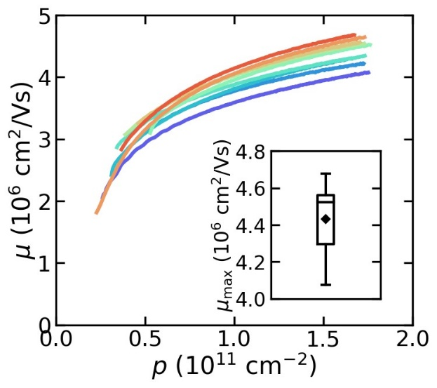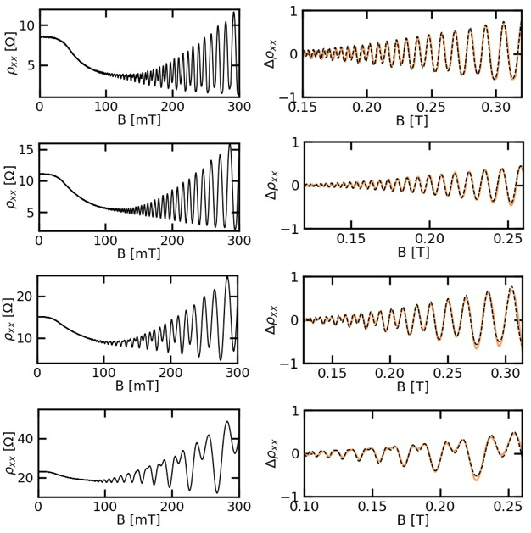
Figure 1, Hall mobility of nine H-FETs in a deep Ge QW. Figure 2, Analytic fit of SdH oscillations.

[1] G. Scappucci et al. Nature Reviews Materials 6, 926-943 (2021)
[2] L.E.A. Stehouwer et al. Applied Physics Letter, 123, 092101 (2023)
[3] D. Costa et al. in preparation (2024)
[4] D. Costa et al. in preparation (2024)

