Single electron control in Si quantum dot arrays in a fully commercial process
Claude Rohrbacher¹, Agostino Aprà², Conor Power², Andrii Sokolov², Xutong Wu², Mathieu Moras¹, Panagiotis Giounanlis², Peter Hanos⁴, Ioanna Kriekouki², Mike Asker³, Dirk Leipold³, Elena Blokhina²
¹ Equal1 Labs, Sherbrooke, J1K 1B7, Canada
² Equal1 Labs, Dublin 4, D04 V2N9, Ireland
³ Equal1 Labs, San Carlos CA 94070, USA
⁴ Equal1 Labs, Timisoara, TM 300124, Romania

In this work we demonstrate the formation and control of quantum dots in a fully
commercial 22nm Fully Depleted Silicon-On-Insulator (FDSOI) process from
GlobalFoundries (FDX). The use of a commercial technology promises scalability
and the cointegration of classical control electronics on the same chip alongside
the quantum dot array.
Reflectometry methods [1] are used to demonstrate Coulomb diamond formation for
a single quantum dot, see Fig.1. Multiple quantum dots can be formed in the channel of the FDSOI quantum dot array. A double dot charge stability diagram is shown in Fig 2., demonstrating control over bias triangles[2], depending on the applied drain-source and tunnel barriers voltages.
Measurement is carried out at 1K, showing a path forward towards hot-qubit operation in a commercial and scalable process technology.
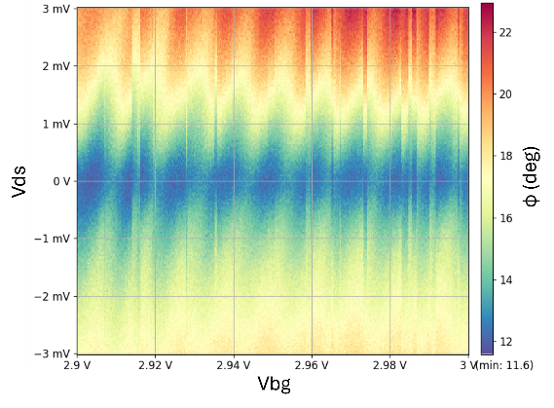
Fig.1. Back-gate versus drain-source voltage, demonstrating Coulomb blockade.
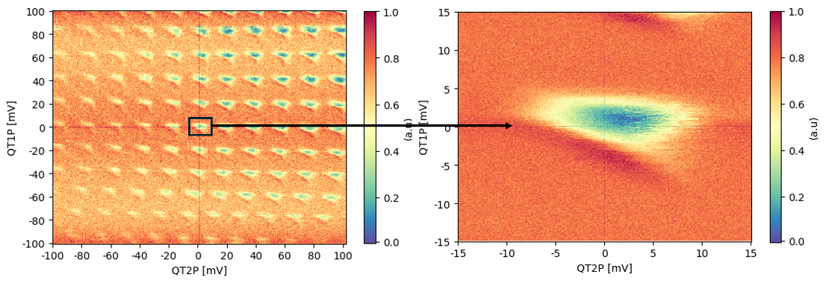
Fig.2. Double quantum dot stability diagram. Typical bias triangles are observed at 900 mK.
[1] F. Vigneau et al., “Probing quantum devices with radio-frequency reflectometry,” Applied Physics Reviews, vol.10, no.2 (2023).
[2] W. G. van der Wiel et al.,“Electron transport through double quantum dots,” Rev. Mod. Phys., vol. 75, no. 1 (2002).

