Noise characterization of a Ge quantum dot and its control electronics
Chun-Yang Yuan ¹, Jo-Yu Wang ¹, Tien-Ho Chang ¹, Jien-Chang Zeng ¹, Chi-Wei Lee ¹, Yin-Chuan Lai ¹, Ruei-Syuan Chiang ¹, Tzu-Kan Hsiao ¹
¹Department of Physics, National Tsing Hua University, Taiwan

In this work we present the noise characterization of a germanium (Ge) quantum dot, focusing on charge noise measurements and noise contributions from the control electronics, specifically the Qblox and QDAC systems. Power spectral density (PSD) analysis identified environmental noise sources, including low-frequency noise and a higher-frequency component around 20 kHz, as well as noise at 60 Hz and its harmonics, attributed to the UPS output and radiation from instrument power supplies. We found part of the noise can be suppressed by adding an isolation transformer and screening the radiation. For the charge noise of the Ge quantum dot, the analysis showed a 1/f dependence, with a noise magnitude on the order of ${10}^{-12}eV^{2}/Hz$ at 1 Hz after normalization by the signal slope and gate voltage lever arm. The low charge noise confirms the good quality of material and fabrication process. These results provide crucial insights into the control electronics noise sources which may affect spin qubit coherence and suggest effective pathways to mitigate these noises, ultimately enhancing qubit stability and coherence.

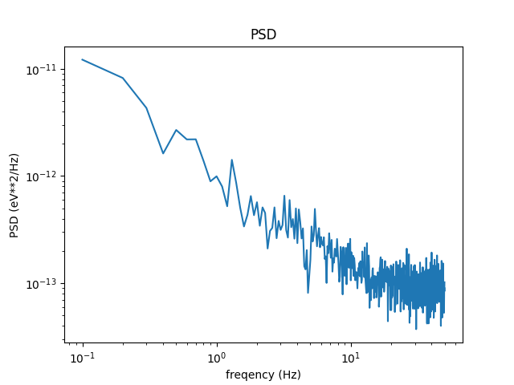

Figure 1, Power Spectral Density of charge noise in a Ge quantum dot, showing a 1/f noise dependence.

