Spin Qubits with Scalable milli-kelvin CMOS Control
Samuel K. Bartee,¹ Will Gilbert,^{2, 3} Kun Zuo,¹ Kushal Das,1 Tuomo Tanttu,2, 3 Chih Hwan Yang,^{2, 3} Nard Dumoulin Stuyck,^{2, 3} Sebastian J. Pauka,¹ Rocky Y. Su,² Wee Han Lim,^{2, 3} Santiago Serrano,^{2, 3} Christopher C. Escott,^{2, 3} Fay E. Hudson,^{2, 3} Kohei M. Itoh,4 Arne Laucht,^{2, 3} Andrew S. Dzurak,^{2, 3} and David J. Reilly¹
¹ARC Centre of Excellence for Engineered Quantum Systems,
School of Physics, The University of Sydney, Sydney, NSW 2006, Australia
²School of Electrical Engineering and Telecommunications,
University of New South Wales, Sydney, NSW 2052, Australia
³Diraq Pty. Ltd., Sydney, NSW, Australia
⁴School of Fundamental Science and Technology, Keio University, Kohoku-ku, Yokohama, Japan

A key virtue of spin qubits is their sub-micron footprint, enabling a single silicon chip to host the millions of qubits required to execute useful quantum algorithms with error correction. With each physical qubit needing multiple control lines however, a fundamental barrier to scale is the extreme density of connections that bridge quantum devices to their external control and readout hardware. A promising solution is to co-locate the control system proximal to the qubit plat- form at milli-kelvin temperatures, wired-up via miniaturized interconnects. Even so, heat and crosstalk from closely integrated control have potential to degrade qubit performance, particularly for two-qubit entangling gates based on exchange coupling that are sensitive to electrical noise. Here, we benchmark silicon MOS-style electron spin qubits controlled via heterogeneously- integrated cryo-CMOS circuits with a low enough power density to enable scale-up. Demonstrating that cryo-CMOS can efficiently enable universal logic operations for spin qubits, we go on to show that milli-kelvin control has little impact on the performance of single- and two-qubit gates. Given the complexity of our milli-kelvin CMOS platform, with some 100-thousand transistors, these results open the prospect of scalable control based on the tight packaging of spin qubits with a ‘chiplet style’ control architecture.

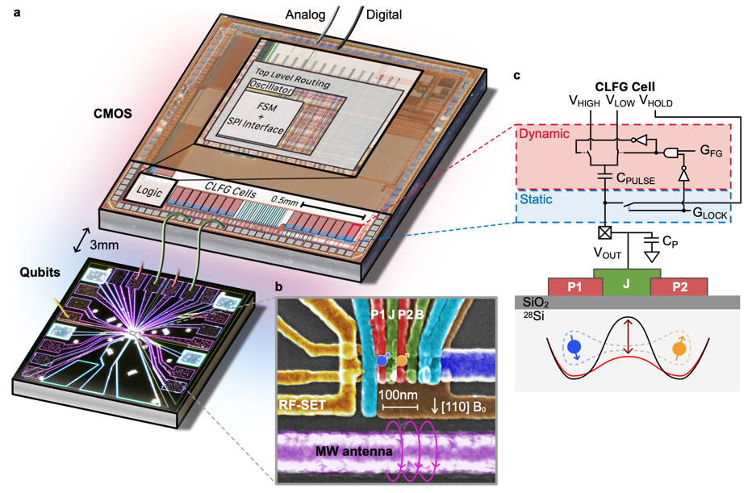
Figure 1, Device and basic CMOS operation

