Implementing RF Reflectometry for quantum dot measurements
Chi-Wei Lee¹, Jian-Chang Zeng¹, Tzu-Kan Hsiao¹
¹Department of Physics, National Tsing Hua University, Taiwan

Radio frequency reflectometry is a useful technique for fast qubit readout, leveraging the impedance difference between distinct qubit states. This difference causes variations in the phase and amplitude of the reflected RF signal, allowing for the determination of qubit states by comparing the signals. In this work, we present the Reflectometry setup used in our laboratory, the pathway from the Arbitrary Waveform Generator (AWG) through the dilution refrigerator to the sample PCB, and the design of our custom-made sample PCB. We observed the resonance of the LC circuit with both commercial and in-house NbTiN inductors using a network analyzer, as shown in figure 1, confirming the validity of our apparatus for RF reflectometry. Finally, we introduce the design of a high-impedance NbTiN resonator, which will be incorporated into a circuit QED architecture for charge-photon and spin-photon coupling in our future work.
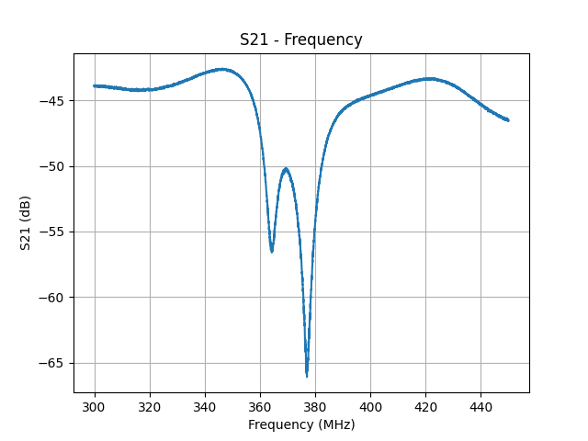
Figure 1, input reflection coefficient of the LC circuit incorporating two NbTiN inductors

