Efficient Microwave Photodetection Using a Frequency-Tunable High-Impedance Resonator Coupled to a Double Quantum Dot
Fabian Oppliger^{1,2}, Wonjin Jang^{1,2}, Franco De Palma^{1,2}, Aldo Tarascio³, Dominik Zumbühl³, Ville Maisi⁴, Pasquale Scarlino^{1,2}
¹Hybrid Quantum Circuit Laboratory (HQC), Institute of Physics, École Polytéchnique Fédérale de Lausanne (EPFL), Lausanne, 1015, Switzerland
²Center for Quantum Science and Engineering, École Polytéchnique Fédérale de Lausanne (EPFL), Lausanne, 1015, Switzerland
³Department of Physics, University of Basel, Klingelbergstrasse 82, CH-4056 Basel, Switzerland
⁴NanoLund and Division of Solid State Physics, Lund University, Lund, Sweden

While highly efficient semiconducting photodetectors are commercially available, it remains challenging to achieve high efficiency in the microwave regime. One approach to achieve this is to couple a microwave resonator to a semiconductor-based quantum dot device and convert incident photons to a photocurrent via photon-assisted tunnelling. Here, we report a photon-to-electron conversion efficiency of ~6% using a superconducting high-impedance resonator coupled to a double quantum dot in a GaAs heterostructure. We observe even higher efficiencies of up to ~80% at operating points with large dot-to-lead cotunneling currents, which requires the development of a more involved theoretical model. Moreover, the frequency-tuneable Josephson junction array resonator allows for measuring the efficiency at different frequencies, enabling a more detailed study of its dependencies. This ongoing work aims to achieve a deeper understanding of the photon-to-electron conversion mechanism, which will help further improve the efficiencies of microwave photodetectors for quantum information applications.

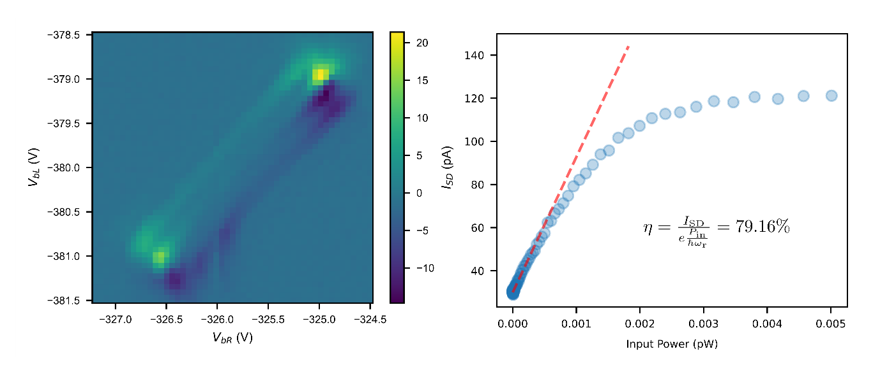
Figure 1, Left: Double quantum dot drain current at an inter-dot charge transition while pumping with the resonator. Right: Photocurrent as a function of resonator input power. The indicated efficiency η is extracted from the linear fit (dashed line) at low input power.

