Simulating the Valley Degree of Freedom in Electron Shuttling in Si/SiO₂
Christian W. Binder^{1,2,*}, Jack J. Turner², Guido Burkard³, Andrew J. Fisher,^{2,4}
¹ Department of Materials, University of Oxford, Parks Road, Oxford OX1 3PH
²Quantum Motion, 9 Sterling Way, London 7HJ
³ Department of Physics, University of Konstanz, D-78457 Konstanz, Germany
⁴ London Centre of Nanotechnology, University College London, Gower St, London WCIE 6BT

* Email: Christian.Binder@materials.ox.ac.uk

Electron shuttling is a key technique for advancing quantum computing, offering reliable electron transfer over long distances with minimal charge loss. Recent studies have shown that motionally induced spin flip errors are negligible, shifting the primary concern to phase errors caused by position- and valley-dependent g-factors. These phase errors become particularly significant at the high velocities required for rapid quantum operations, posing a challenge to achieving the high fidelities necessary for error correction schemes. Notably, the valley-dependent g-factor variation remains inadequately addressed by existing analytical methods, which cannot fully capture the complexities of an electron shuttled along a rough surface. We address this critical gap by developing a novel, fast, and stable numerical approach to study electron shuttling, accurately capturing the essential physics of the valley degree of freedom in both time-dependent and time-independent contexts. This approach provides a comprehensive tool for understanding the time-evolution of the valley-orbit electronic wavefunction during shuttling. Our method significantly enhances the understanding of electron shuttling dynamics and might hence contribute to the efforts of mitigating shuttling-induced phase errors. We validate our approach through rigorous benchmarking between numerical and analytical techniques and tackle a variety of valley-induced problems. Specifically, we investigate the impact of surface roughness on the excitation of the valley degree of freedom during shuttling, the influence of quantum dot size on these excitations, and the effects of noise-induced trajectory variations on phase errors. 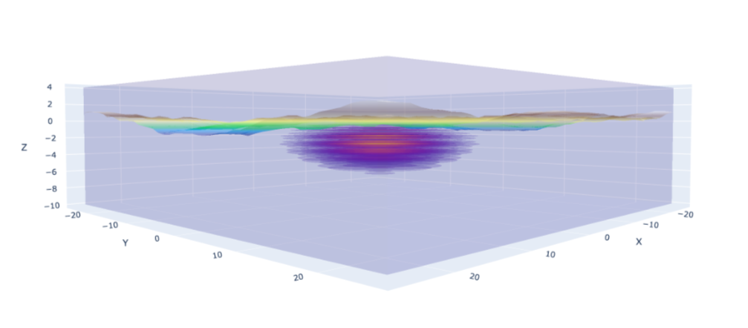
Fig 1.: A quantum dot generated using our novel approach. The figure illustrates the electronic wavefunction of the quantum dot, confined by a harmonic potential to a rough interface. The ripples in the wavefunction highlight the valley texture, a natural feature emerging from our method.

