Certifying the quantumness of a single nuclear spin qudit through its uniform precession
Arjen Vaartjes,^{1, 2} Martin Nurizzo,^{1, 2} Lin Htoo Zaw,³ Benjamin Wilhelm,^{1, 2,}, Xi Yu,^{1, 2} Danielle Holmes,^{1, 2} Daniel Schwienbacher,^{1, 2} Anders Kringhøj,^{1, 2} Mark R. van Blankenstein,^{1, 2} Alexander M.Jakob,^{4, 2} Fay E. Hudson,¹ Kohei M. Itoh,⁵ Andrew S. Dzurak,¹ David N. Jamieson,^{4, 2} Valerio Scarani,³ and Andrea Morello^{1, 2}
¹ School of Electrical Engineering and Telecommunications, UNSW Sydney, Sydney, NSW 2052, Australia
² ARC Centre of Excellence for Quantum Computation and Communication Technology
³ Centre for Quantum Technologies, National University of Singapore, 3 Science Drive 2, Singapore 117543
⁴ School of Physics, University of Melbourne, Melbourne, VIC 3010, Australia
⁵School of Fundamental Science and Technology, Keio University, Kohoku-ku, Yokohama, Japan

Although qubits are prime examples of quantum systems, single qubits can only host semi-classical spin coherent states. Qudits, on the other side, can exhibit non-classical states, which cannot be described by a classical probability distribution. Here we detect quantumness in the time evolution of a uniformly precessing 8-dimensional nuclear qudit. In this experiment quantumness is certified by asking how often the x coordinate of a uniformly precessing state is positive. A violation of a classical bound in this protocol indicates the absence of a classical probability distribution that can explain the observed data, thus confirming quantumness. We present our experimental demonstration of this protocol focusing on a family of non-classical states in a spin-7/2 123Sb nucleus, implemented within a silicon nano-electronic device. Our results reveal a significant violation of the classical protocol bound, surpassing it by 19 standard deviations for the spin-cat state. These findings underscore our ability to prepare arbitrary nonclassical resource states with high fidelity in a single atomic-scale qudit, with potential applications in quantum information processing, sensing and quantum error correction.
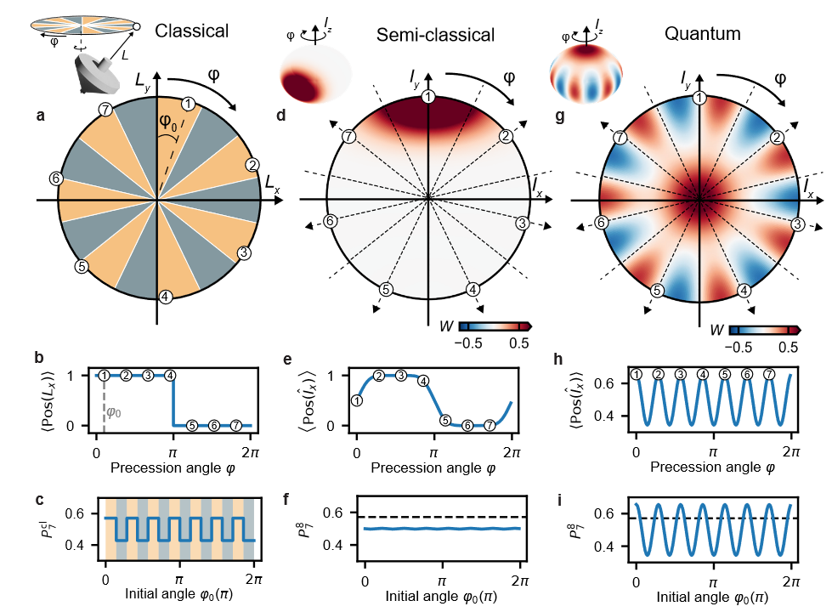
Figure 1, Protocol applied for a classical gyroscope, a spin coherent state and a spin cat state

