Rf readout with NbTiN high kinetic inductor
Desmond Kim Chye, Cheng¹, Chun-Lun, Wang², Jian-Chang, Zeng¹, Tien-Ho, Chang¹,
Chia-Hao, Wei¹, Chi-Wei, Lee¹, Ming-Jye, Wang², and Tzu-Kan, Hsiao¹.
¹Department of Physics, National Tsing Hua University
²Institute of Astronomy and Astrophysics, Academia Sinica

Radio frequency (rf) reflectometry is essential for fast qubit readout. In our work, we utilize high kinetic inductance niobium titanium nitride (NbTiN) as inductors for the tank circuit in rf reflectometry. We vary the design of the NbTiN inductors for different selected resonant frequencies. Two inductors were wire bonded on a printed circuit board (PCB) and loaded in a dilution refrigerator. Four-point probe measurements and rf spectrum analysis were performed simultaneously as the dilution refrigerator cooled down. The critical temperature of the NbTiN inductor was measured to be 6.5 K, and a resonance peak was observed at about 376 MHz, with the sheet inductance and parasitic capacitance estimated to be 76 pH and 0.5 pF respectively. Future works include utilizing another high kinetic inductance material, titanium nitride (TiN), as inductors, and perform multiplex readout with the different inductance of the inductors.

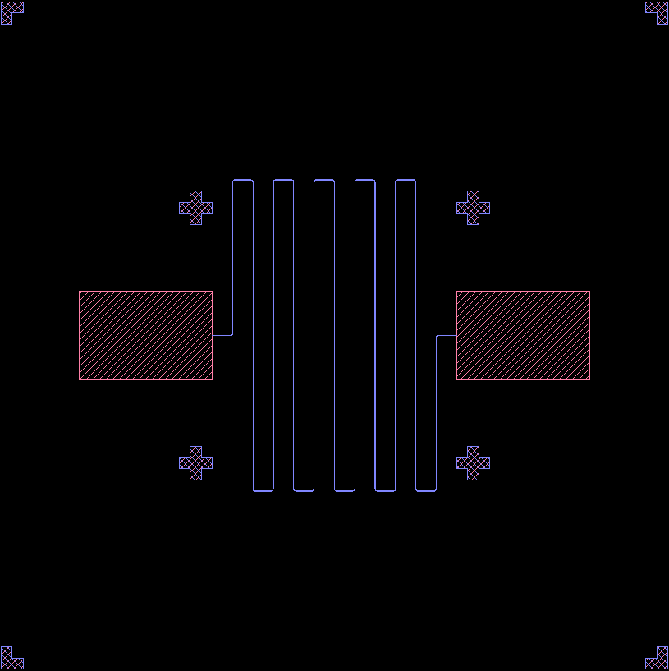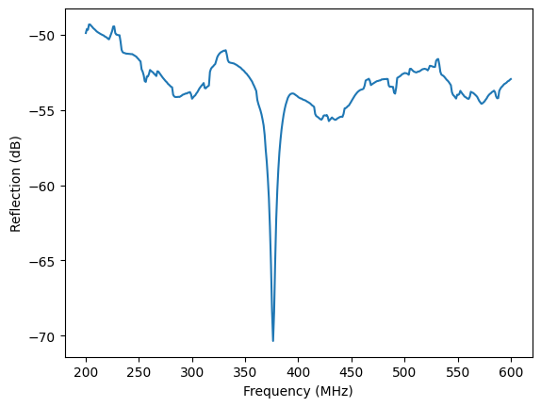
Figure 1, Inductor design. Figure 2, Resonance peak of tank circuit

