Solving Systems of Linear Equations with a 4-Qubit Spin Register in Silicon
Henric Bornemann^{1,2}, Ian Thorvaldson^{1,2}, Dean Poulos¹, Christian M. Moehle¹, Jonathan Reiner¹, Christian Lehner¹, Joris G. Keizer^{1,2}, Yousun Chung¹, Ludwik Kranz^{1,2}, Benoit Voisin¹, Samuel K. Gorman^{1,2}, Charles D. Hill^{1,2}, Michelle Y. Simmons^{1,2}
¹Silicon Quantum Computing Pty Ltd., UNSW Sydney, Australia
²Centre of Excellence for Quantum Computation and Communication Technology, UNSW Sydney, Australia

Spin qubits in silicon have rapidly advanced in recent years, moving from a single-qubit testbed to small multi-qubit processors. However, demonstrations of small-scale quantum algorithms have been limited to three qubits in part due to the limited qubit connectivity in spin qubit processors. Spin registers hosted by phosphorus atoms in silicon natively support all-to-all connectivity and have recently demonstrated single-qubit and two-qubit gate fidelities exceeding 99 % [1]. Here, we implement the 4-qubit Harrow-Hassidim-Lloyd (HHL) [2] algorithm on a spin register in silicon. We investigate the performance of the HHL algorithm under different input assumptions: one in which the key states are simply stepwise encoded in the circuit and one in which the subroutines are implemented in full. We characterize both versions using non-trace preserving quantum process tomography and achieve fidelities of 93.4(5) % and 89.1(5) % for the simplified and the full circuit, respectively. The reduction in fidelity emphasizes the benefits of running quantum algorithms on a highly interconnected platform for reducing errors. Exchange-based electron gates between spin registers [3] are currently being investigated for further extensions to the HHL algorithm.

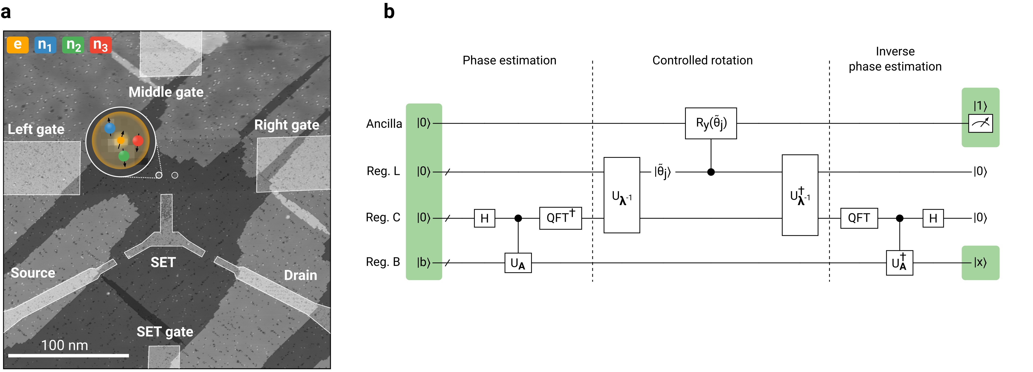
Figure 1. a) Scanning tunnelling micrograph of the 4-qubit quantum processor. The inset highlights the spin register, consisting of one electron spin (yellow) and three phosphorus nuclear spins (blue, green, and red). b) Generalized quantum circuit for the HHL algorithm. The algorithm solves systems of linear equations by finding the vector $\vec{x}$ that satisfies $A\vec{x}=\vec{b}$.

[1] I. Thorvaldson et.al., arXiv:2404.08741 (2024)
[2] A. W. Harrow et al., Phys. Rev. Lett., 103 (2009) 150502
[3] Y. He et al., Nature, 571 (2019) 371-375

