Benchmarking single-qubit gate with 99.99% fidelity via pulse shaping in silicon spin qubits
Akito Noiri¹, Yi-Hsien Wu¹, Leon Camenzind¹, Patrick Bütler¹, Kenta Takeda¹,
Takashi Nakajima¹, Takashi Kobayashi¹, Ik Kyeong Jin¹,
Giordano Scappucci², Seigo Tarucha¹
¹RIKEN
²QuTech and Kavli Institute of Nanoscience

Implementing fault-tolerant code is essential for achieving large-scale quantum computing. To implement fault-tolerant codes, we need qubits with gate operation fidelity above a certain threshold, usually 99%, under a common decoding scheme. Improving this gate fidelity will reduce the number of physical qubits required to achieve the same logical error rates.
Here, we investigate the fidelity of single-qubit gates for five qubits in Si/SiGe quantum dots with a micromagnet. We compare single-qubit gates with different control pulses and achieve single-qubit gate fidelities >99.99% with a Kaiser envelope pulse for all qubits consistently (Figure 1). We investigate the effect of driving speeds and interval times on the gate fidelities with both rectangular and Kaiser shaped pulses.
We also find that the shaped envelope pulse improves fidelity of simultaneously driven single qubit gates. These ultra-high-fidelity gates will improve the prospect of implementing fault-tolerant codes with silicon spin qubits.

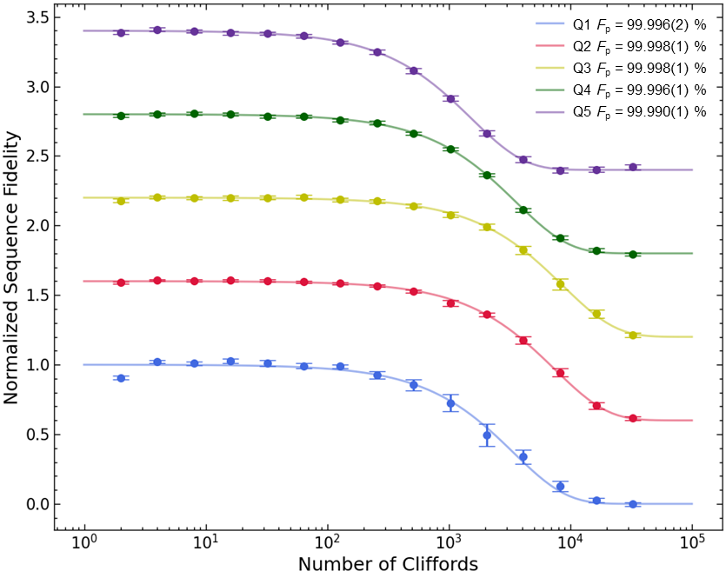
Figure 1, Randomized benchmarking results of single-qubit gate for the five qubits.

