Tuning of multi-dot devices in SiMOS
Andreas Nickl¹, Tuomo Tanttu^{1,2}, Santiago Serrano^{1,2}, Wee Han Lim^{1,2}, Fay E. Hudson^{1,2}, Andre Saraiva^{1,2}, Andrew S. Dzurak^{1,2}, and Arne Laucht^{1,2}
¹School of Electrical Engineering and Telecommunications,
The University of New South Wales, Sydney, NSW 2052, Australia
²Diraq, Sydney, NSW 2052, Australia

Electron spins in Silicon-MOS devices are a promising platform to realize qubits for a large-scale quantum processor. Their small footprint, combined with the well-established fabrication methods from the classical nano electronics industry and research, allows dense packing of qubit arrays [1]. Single and two-qubit gate fidelities above the error correction threshold have been reported at temperatures above 1K, enabling operation in cryostats with high cooling power compared to the mK regime [2]. So far, demonstrations in SiMOS are restricted to the single and two qubit regimes. In this work we show recent advances of tuning and calibration as well as simultaneous control of single and two qubit gates in larger linear spin qubit arrays. We use a reinforcement-learning model to find and optimize initialization and readout of parity spin states by Pauli spin blockade [3]. This automated method accelerates the calibration process at least tenfold and gives access to a higher parameter space than comprehendible by a human experimentalist.
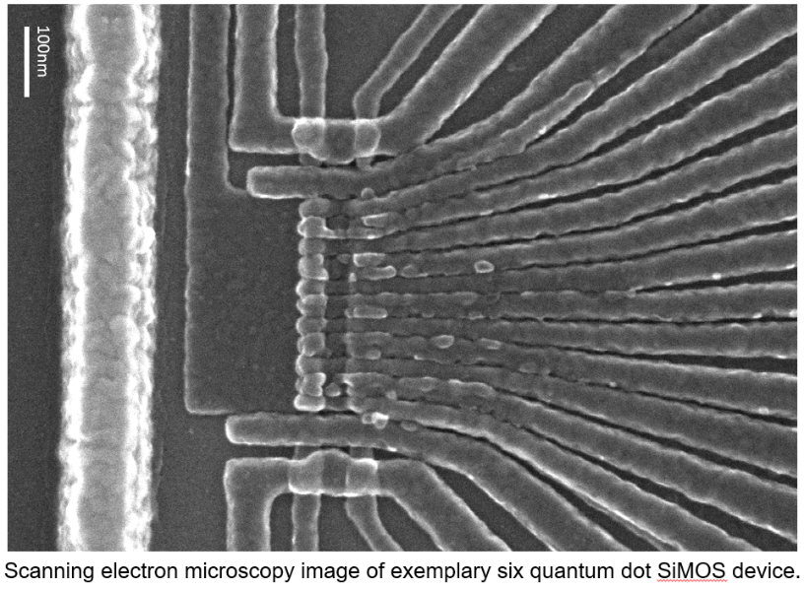
Figure 1, Scanning electron microscopy image of exemplary six quantum dot SiMOS device

[1] Veldhorst, M., Yang, C., Hwang, J. et al. A two-qubit logic gate in silicon. Nature 526, 410–414 (2015). https://doi.org/10.1038/nature15263
[2] Huang, J.Y., Su, R.Y., Lim, W.H. et al. High-fidelity spin qubit operation and algorithmic initialization above 1 K. Nature 627, 772–777 (2024). https://doi.org/10.1038/s41586-024-07160-2
[3] Seedhouse, A. E., Tanttu, T., Leon, R. C. C. et al. (2021). Pauli Blockade in Silicon Quantum Dots with Spin-Orbit Control. PRX Quantum, 2(1), 010303. https://doi.org/10.1103/PRXQuantum.2.010303

