Modeling Si/SiGe quantum dot variability induced by interface disorder reconstructed from multiperspective microscopy
L. F. Peña,¹ J. C. Koepke,¹ J. H. Dycus, ² A. Mounce,¹ A. D. Baczewski,¹ N. T. Jacobson,¹
and E. Bussmann¹
¹ Sandia National Laboratories, Albuquerque, NM 87185 USA
² Advanced Microscopy, Eurofins EAG Materials Science, Raleigh, NC 27606 USA
Nano-scale quantum dot (QD) qubits in SiGe exhibit competitive quantum characteristics, e.g. long coherence times, required of future quantum information technologies. A challenge in developing the SiGe platform lies in understanding relationships between interface structure and quantum electronic properties. For example, atomic disorder at Si/SiGe interfaces is theoretically predicted to strongly modulate the conduction band valley spitting (VS). This atomic-scale interface structure-to-electronic-function relationship may be a determining factor in manufacturability of SiGe qubits. However, to simply measure, deconvolve, and visualize solid-embedded few-atomic-layer interface structures spanning any appreciable volume is extremely challenging. Interfacial atomic disorder descriptions that span over application-relevant ensembles are only partially tractable with post-synthesis microscopy (transmission electron microscopy) or tomography (atom-probe tomography), owing to issues such as image convolution and limited sampling volumes. To yield more comprehensive multiscale yet atomistic heterointerface descriptions, we use a multimodal microscopy approach. By convolving data from scanning tunneling microscopy and high-angle annular dark field scanning transmission electron microscopy, we reconstruct 3D interfacial atomic structure and employ an atomistic multi-valley effective mass theory to quantify qubit spectral variability. The results indicate (1) appreciable VS variability of ~50% owing to alloy disorder and (2) roughness-induced double-dot detuning bias energy variability of order 1–10 meV depending on well thickness. For measured intermixing, atomic steps have negligible influence on VS, and uncorrelated roughness causes spatially fluctuating energy biases in double-dot detunings, potentially incorrectly attributed to charge disorder. Our approach yields atomic structure spanning orders of magnitude larger areas than post-growth microscopy or tomography alone, enabling more holistic predictions of disorder-induced qubit variability and of significance for understanding performance limits in quantum electronics applications.
Fig.1 An overview of our approach and results studying Si/SiGe interface disorder, including interface roughness and intermixing effects, to drive models for disorder-induced quantum dot variability, e.g., valley splitting variability. Adapted from L.F. Peña et al. npj Quantum Information 10, 33 (2024), CC 4.0 Int’l license.
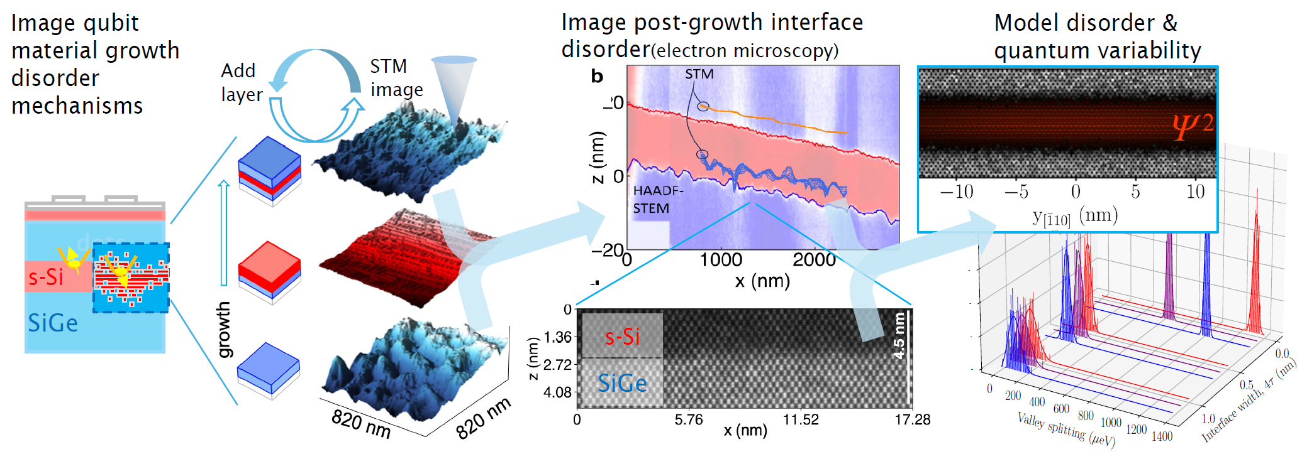
This work was performed, in part, at the Center for Integrated Nanotechnologies, an Office of Science User Facility operated for the U.S. Department of Energy (DOE) Office of Science. Sandia National Laboratories is a multimission laboratory managed and operated by National Technology & Engineering Solutions of Sandia, LLC, a wholly owned subsidiary of Honeywell International, Inc., for the U.S. DOE’s National Nuclear Security Administration under contract DE-NA-0003525. The views expressed in the article do not necessarily represent the views of the U.S. DOE or the United States Government.

