Progress Towards Levitated Electron Qubits on Neon
A. Palmer¹, K. Matkovic^{1,2}, P. Russell^{1,2}, L. Delventhal¹, K. Zuo³, M. Cassidy¹
¹ School of Physics, University of New South Wales
² School of Electrical Engineering, University of New South Wales
³ ARC Centre of Excellence for Engineered Quantum Systems and School of Physics, University of Sydney

Electrons on helium/neon are levitated by the attraction of mirror charges balanced by repulsion from the large potential barrier at the surface. This isolates the electron from sources of decoherence, presenting a promising path for qubits with long coherence times and fast operations [1]. The coherence time of these levitated electrons’ spin states is predicted to exceed 100s [2]. Solid neon as a substrate may offer advantages over superfluid helium, such as higher tolerance for mechanical vibrations and higher operating temperatures [3]. Recent demonstrations have shown electron charge qubits on neon with coherence times of 0.1ms and qubit gate fidelities exceeding 99.95% [4].
We report progress in realizing a qubit in this system. We studied the neon growth process by measuring changes in frequency and quality of an array of resonators after neon deposition. We mapped neon crystal growth to assess different deposition and annealing processes for thin neon crystals. Through these depositions, we observed increasing resonator quality factors, even after neon removal, attributed to the removal of contaminants on the superconducting films by the deposition process. We are investigating two resonator designs for trapping the electrons and report the latest simulation and measurement results. One resonator uses a tuning fork design (Fig 1) and the other uses a split ring design (Fig 2).

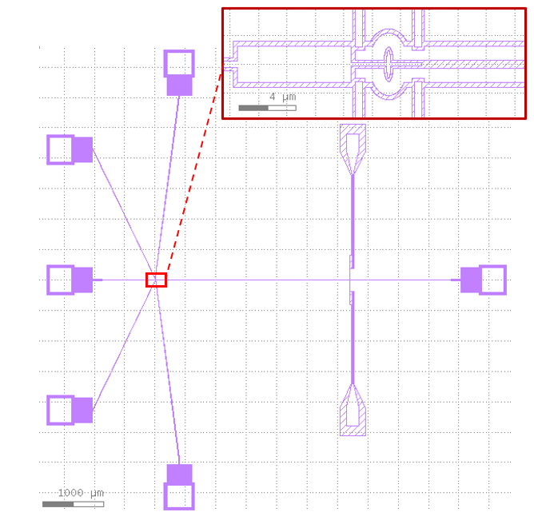
Figure 1, Tuning Fork Resonator Design
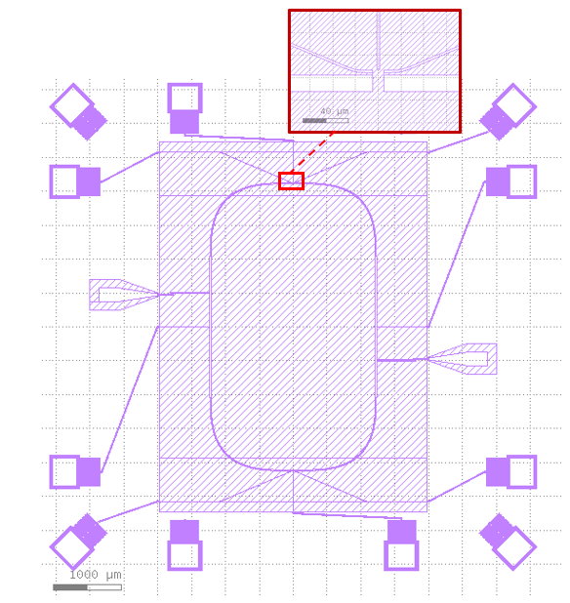
Figure 2, Split Ring Resonator Design
References
[1] D. Schuster et al. Proposal for Manipulating and Detected Spin and Orbital States of Trapped Electrons Using Cavity Quantum Electrodynamics, Phys. Rev. Lett. 105, 040503 (2010)
[2] S. Lyon, Spin-based quantum computing using electrons on liquid helium, Phys. Rev. A 74, 052338 (2006)
[3] V Zavyalov et al. Electron States above the Surfaces of Solid Cryodielectrics for Quantum-computing, J Low Temp Phys 138, 415–420 (2005)
[4] X. Zhou et al. Electron charge qubit with 0.1 millisecond coherence time, Nat. Phys. 20, 116–122 (2023)

