Development of piezoelectric actuators for strain control of donor spin qudits
Laura A. O’Neill¹, Daniel Schwienbacher¹, Danielle Holmes¹, Benjamin Joecker¹, Andrew D. Baczewski² and Andrea Morello¹
¹CQC2T, School of Electrical Engineering & Telecommunications, UNSW Australia, Sydney NSW 2052 Australia
²Center for Computing Research, Sandia National Laboratories, Albuquerque, New Mexico 87123, USA

Localised control of coherent qubits is crucial for scalable quantum computing. High spin nuclear donor qudits, such as spin-7/2 ¹²³Sb, are highly coherent and possess a quadrupole moment that enables localised electric and acoustic control [1]. We designed a silicon-based quantum device capable of achieving nuclear acoustic resonance (NAR) of an ¹²³Sb donor using oscillating strain induced by a piezoelectric actuator [2]. Fabrication of the nanoscale piezoelectric AlN strip (60-80 nm wide, 650 nm long and 50-100 nm thick) on our silicon-based quantum device has proven to be challenging, since traditional dry etching techniques require etch stops, such as HfOx, that are known to introduce charge noise. Hence, we propose alternate fabrication process flows to dry etching AlN and present first results on 500 nm thick highly c-axis oriented AlN samples supplied by Argonne National Laboratories.
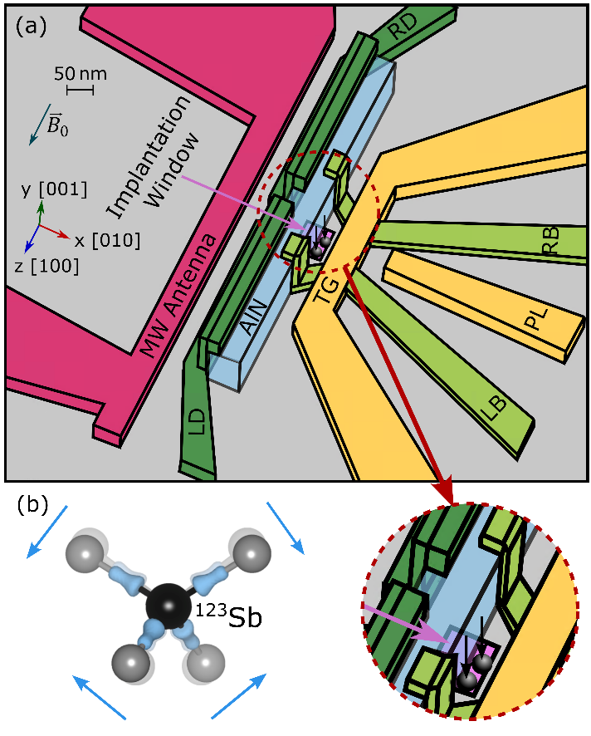
Figure 1: (a) COMSOL simulated NAR device with a 60 nm wide, 100 nm thick AlN strip electrically
connected to the barrier gates (LB and RB) and donor gates (LD and RD).
(b) Diagram of strain-induced atomic bond distortion for a ¹²³Sb donor (black) in silicon (grey),
which creates an electric field gradient (EFG) modulation $δV$ that interacts with the ¹²³Sb
nucleus’ electric quadrupole moment and enables NAR.
[1] Asaad et al., Nature 579, 205–209 (2020)
[2] O’Neill et al., Appl. Phys. Lett. 119, 174001 (2021)

