Investigating Source of Spurious Dots in 300 mm Process Quantum Devices by Triangulation
Kuan-Chu Chen^{1,2}, Clement Godfrin¹, George Simion¹, Imri Fattal^{1,3}, Bart Raes¹, Arne Loenders^{1,3}, Danny Wan¹, Kristiaan De Greve^{1,3}
¹IMEC, Leuven, Belgium
²NSTC, Taipei, Taiwan
³KU Leuven, Leuven, Belgium

The presence of spurious dots presents a challenge to scaling quantum devices. Previous studies have attributed their formation to factors such as strain[1], unintentional doping[2], surface roughness[3], and oxide charges[4]. However, the causes are highly dependent on materials, fabrication processes, and device architecture, making it difficult to identify the dominant contributors without further analysis. In this work, we employ the electrostatic triangulation technique, as detailed in Ref.[5], to statistically locate spurious dots in eighteen single-electron transistors (SETs) with three oxide thicknesses, fabricated using a 300 mm process. The objective is to identify the primary factors leading to spurious dot formation.
Fig. 1(a) shows a scanning electron microscope (SEM) image of the SETs. The main dot is defined by the left barrier (LB), right barrier (RB), SET top (ST), and confinement (C) gates. In these SETs, the source and drain doping regions are positioned several microns away to avoid spurious dots caused by unintentional doping, while polysilicon gates are employed to minimize strain. We monitor unexpected Coulomb blockade oscillations during the tuning of the barriers and main dot, and then use triangulation to locate the spurious dots. Fig. 1(b) illustrates the distribution of triangulated spurious dots found in the six SETs with a 12 nm gate oxide thickness. It is observed that spurious dots frequently emerge near the edges and corners of the LB and RB gates, suggesting that strain is the primary cause.
To further investigate, we perform electrostatic potential and strain simulations to obtain the conduction band energy profile. By solving the Schrödinger equation with the obtained energy profile, we determine the electron distribution. Fig. 1(c) shows the normalized electron concentration from the simulation, revealing that, in addition to the conducting path beneath the ST gate, electrons also accumulate at the edges and corners of the LB and RB gates, consistent with the locations of the spurious dots.
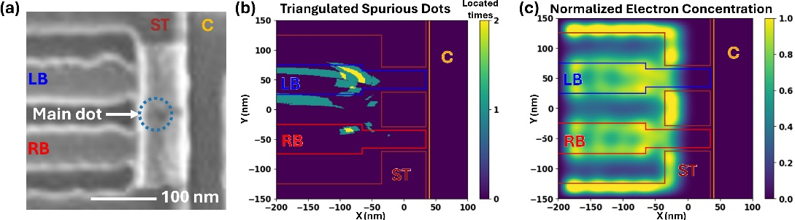
Figure 1, (a) Scanning electron microscope (SEM) image of the single-electron transistors (SETs). (b) Triangulated spurious dots for six SETs with a 12 nm gate oxide thickness. (c) Normalized electron concentration from simulations.
[1] T. Thorbeck et al. AIP Adv. (2015).
[2] G. P. Lansbergen et al. Nat. Phys (2008).
[3] B. Voisin, et al. Nano Lett. (2014)
[4] E. P. Nordberg et al. Phys. Rev. B (2009).
[5] I. Kriekouki et al. Solid State Electron. (2022).

