Quantum computing in vertically coupled double quantum dots
Hanifa Tidjani¹, Dario Denora¹, Menno Veldhorst¹
¹QuTech and Kavli Institute of Nanoscience, Delft University of Technology, P.O. Box 5046, Delft 2600 GA, The Netherlands

Large qubit counts and high connectivity are crucial for advancing quantum computers. However, scaling efforts for semiconductor-based spin qubits have mostly been limited to one- or two-dimensional arrays. We recently demonstrated that vertical double quantum dots can be formed by biasing a bilayer germanium heterostructure, forming arrays scaled in the z-direction [1,2]. Building on this work, we investigate how vertically coupled quantum dots can be operated as spin qubits, and how their properties differ from planar implementations. This is done on a bilayer geranium quantum well heterostructure, with a 10nm SiGe spacer between the quantum wells. We operate in ‘isolated mode’, where the total number of holes remains fixed due to minimal dot-reservoir coupling. The greater working voltage window afforded by working in isolated mode enables us to perform diabatic spin shutting between layers in a three-spin, four-quantum dot configuration, and observe hopping induced oscillations due to the difference in quantisation axis [3], see figure 1. Potential engineering of the quantisation axis of the dots in different layers may provide a path to hopping based qubits with engineered quantisation axis. This demonstration of coherent operation of bilayer devices opens the door to new research avenues in quantum simulation and computation, with higher connectivity than previously possible.
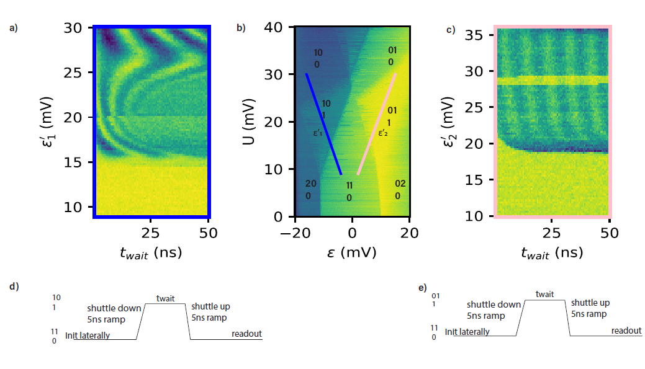
Figure 1, Diabatic shuttling of a spin in a vertical configuration. a) (c) The oscillations induced by shutting along the blue (pink) line in b, which shows the isolated mode charge stability diagram for the triple dot, where there is one vertical double dot. The pulse sequence is outlined in (d) and (e)
[1] H. Tidjani et al Phys. Rev. Applied 20 (054035) (2023)  [2] A.S. Ivlev et al Applied Physics Letters 125 (2) (2024) | 2 | 2024
[3] C.A. Wang et al Science 385 (6707), 447-452 (2024)

