Floquet interferometry of a dressed semiconductor quantum dot
Felix-Ekkehard von Horstig^{1,2,*}, Lorenzo Peri^{1,2,*}, Sylvain Barraud³, Sergey N. Shevchenko⁴, Christopher J. B. Ford², M. Fernando Gonzalez-Zalba¹
¹Quantum Motion, London, United Kingdom
²Cavendish Laboratory, University of Cambridge, Cambridge, United Kingdom
³CEA, LETI, Minatec Campus, Grenoble, France
⁴B. Verkin Institute for Low Temperature Physics and Engineering, Kharkiv, Ukraine
*These authors contributed equally to this work.

A quantum system interacting with a time-periodic excitation creates a ladder of hybrid eigenstates in which the system is mixed with an increasing number of photons. This mechanism, referred to as dressing, has been observed in the context of light-matter interaction in systems as varied as atoms, molecules and solid-state qubits [1].
In this work, we demonstrate state dressing in a semiconductor quantum dot tunnel-coupled to a charge reservoir. We observe the emergence of a Floquet ladder of states in the system's high-frequency electrical response, manifesting as interference fringes at the multiphoton resonances despite the system lacking an avoided crossing and transitions being allowed solely via stochastic charge exchanges with the reservoir that erase the charge's quantum phase.
We study the dressed quantum dot while changing reservoir temperature, charge lifetime, and excitation amplitude and reveal the fundamental nature of the mechanism by developing a theory based on the quantum dynamics of the Floquet ladder [2], which is in excellent agreement with the data. Furthermore, we show how the technique finds applications in the accurate and fast electrostatic characterisation of semiconductor quantum dots.

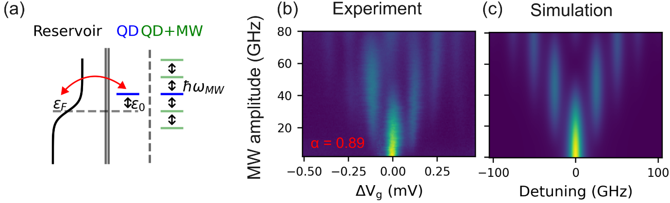
Figure 1, (a) Energy-level schematic showing a reservoir and a QD. When a microwave tone is applied to the QD it splits into a ladder of Floquet states separated by the photon energy ℏω_{MW}. (b) Experiment and (c) Simulation of QD response against MW amplitude and detuning for ω_{MW}/2π = 25.3 GHz. The lever arm α can be extracted from the level splitting in detuning.

[1] M Rodriguez-Vega et al 2018 New J. Phys. 20 093022
[2] L. Peri et al., Quantum 8, 1294 (2024)
This work is available for preprint under arxiv:2407.14241

