Autonomous rf-Tuning into Pauli Spin Blockade using Neural Networks
Cornelius Carlsson¹, Jaime Sáez-Mollejo², Georgios Katsaros², Natalia Ares¹
¹Department of Engineering Science, University of Oxford, Oxford OX1 3PJ, United Kingdom
²Institute of Science and Technology Austria, Am Campus 1, 3400 Klosterneuburg, Austria

Machine learning methods have emerged as valuable tuning agents for semiconductor quantum dot systems. They relieve the need for heuristic measurements and often provide significant speed-ups over human experts [1, 2]. A notable achievement in this field has been the fully autonomous tuning of a spin qubit [3]. By delegating the decision-making process to machines, however, the primary bottleneck falls on the time spent acquiring data. High-bandwidth measurement techniques, such as radio-frequency (rf) reflectometry, address this challenge, yet auto-tuning efforts in the rf-domain beyond double-dot formation are currently lacking [4, 5].
In this work, we demonstrate machine learning methods for the autonomous rf-tuning into Pauli spin blockade (PSB). Finding a voltage regime that exhibits PSB can be notoriously difficult, albeit necessary for common spin initialisation and read-out schemes. We implement our routine in a depletion mode Ge/SiGe heterostructure, starting from a double-dot charge stability diagram. From there, we use neural networks to: i) locate interdot transitions, ii) extract transition line features, iii) construct triangular masks enclosing candidate PSB regions, and iv) virtualise gate voltages. Our sequence of networks operates within a voltage optimisation loop, assigning a PSB score to each tested voltage configuration. High scores correspond to the emergence of a meta-stable triplet state during pulsed measurements – a characteristic feature of PSB. Upon using the proposed voltage settings, we are able to drive a singlet-triplet qubit, thus confirming the successful tuning into the PSB window. This work marks a crucial step in the auto-tuning of semiconductor spin qubits using rf reflectometry, paving the way towards a fully automated rf pipeline for fast qubit tuning.

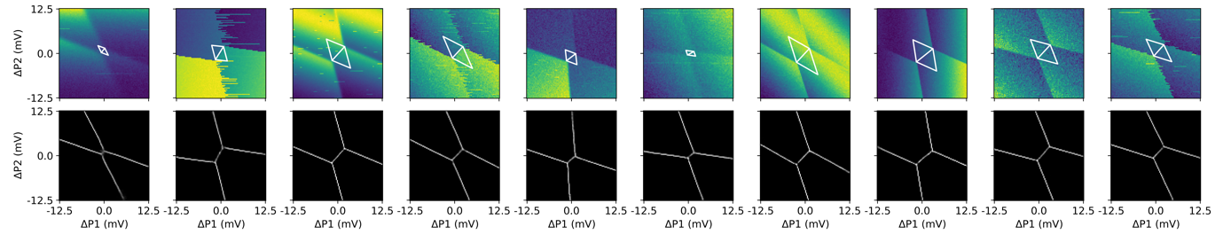
Figure 1, Simulated charge-sensing measurements of an interdot transition (top) with transition lines extracted using an auto-encoder neural network (bottom). The network output enables the automatic masking of candidate meta-stable regions, outlined by the white triangles.

[1] Moon, H., Lennon, D.T., Kirkpatrick, J. et al. Nat Commun 11, 4161 (2020).
[2] Severin, B., Lennon, D.T., Camenzind, L.C. et al. Sci Rep 14, 17281 (2024).
[3] Schuff, Jonas, et al. arXiv preprint arXiv:2402.03931 (2024).
[4] van Straaten, Barnaby, et al. arXiv preprint arXiv:2211.04504 (2022).
[5] Hickie, Joseph, et al. arXiv preprint arXiv:2310.02135 (2023).

