Fabrication and measurement of a Ge/SiGe quantum dot device
T.H. Chang, J.C. Zeng, C.H. Wei, R.S. Jiang, C.W. Lee, C.Y. Yuan, R.Y. Wang, Y.Q. Lai, G.L. Luo, D.J. Zhuo, T.K. Hsiao
Department of physics, National Tsing Hua University, Taiwan

Presenter: Tien-Ho Chang
Affiliation: Department of Physics, National Tsing Hua University (master’s student)
Contact: hertz.tera@gmail.com
Due to several advantages such as high mobility, strong spin orbit coupling, and low effective mass, Germanium hole-spin qubits have become a promising platform for quantum computing. Demonstration of long coherence times and the potential for scale up thanks to its compatibility with industrial nanofabrication techniques also contributes to its potential.

In this poster we will demonstrate our measurements of a germanium double quantum dot device, measured in a 10mK environment. Our device is fabricated in house on a locally grown germanium quantum well heterostructure with a single aluminium fine gate layer covered by a global accumulation gate that allows for easier alignment in fabrication. The device is loaded on a custom-made sample PCB and measured in an Oxford Proteox fridge equipped with a RF reflectometry readout system.

We have tuned up a quantum dot device, observed Coulomb blockade and Coulomb diamond using both DC transport and RF reflectometry. We also measured charge noise spectrum of a quantum dot, which is similar to the values reported in the literature, confirming the quality of substrate material, fabrication processes and measurement setup. This work lays the foundation for Ge hole spin qubit control and quantum simulation experiments in our lab.

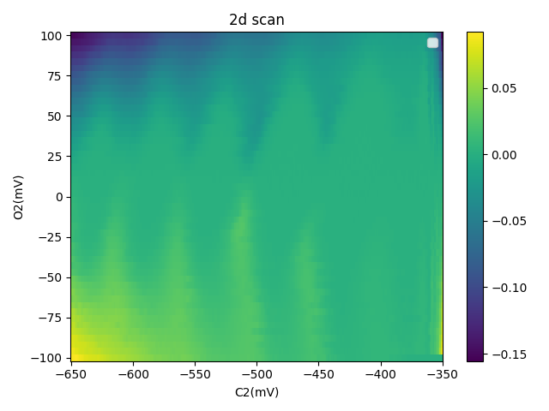
Coulomb diamond of charge sensor

