QARPET: Qubit Array Research Platform for Engineering and Testing
Federico Poggiali¹, Asser Elsayed¹ , Alberto Tosato¹, Davide Degli Esposti¹, Lucas E. A. Stehouwer¹, Menno Veldhorst¹, Giordano Scappucci¹
¹ QuTech and Kavli Institute of Nanoscience, Delft University of Technology, Lorentzweg 1, 2628 CJ Delft, Netherlands
Germanium spin qubits are emerging as a promising technology for spin-based quantum processors based on electrostatically defined quantum dots. Advancements in optimizing Ge-based materials and a deeper understanding of their fundamental physics are essential to drive progress. Traditional hero device-style measurements are no longer sufficient to achieve the required progress. To meet these demands, large-scale cryogenic characterization and statistical analysis, integrated into the design cycle of Ge-based quantum devices, are mandatory.
Our architecture, Qarpet, is tailored for large-scale characterization of quantum dot qubits and features a cross-bar array of repeating unit cells, each comprising a sensing dot and qubit dots. We showcase the operation of single-hole transistors for sensing dots and last-hole occupation for qubit dots. We then provide a detailed statistical investigation of charge noise, further discussing the potential for high-volume qubit measurements, and present proof-of-concept results paving the way for future characterization endeavors.

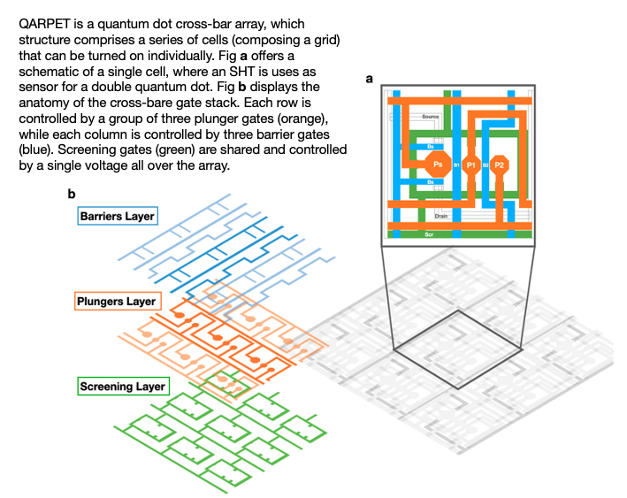
- Name of presenter: Federico Poggiali
- Presenter’s main affiliation: Tu Delft, Qutech, Scappucci’s Group
- Presenter’s position: PhD Student
- Abstract title: QARPET: Qubit Array Research Platform for Engineering and Testing
- Email contact: f.poggiali@tudelft.nl

