From an empty lab to customized setups and germanium quantum dots
Niels Focke*¹, Lino Visser*¹, Spandan Anupam¹, Marc Neis², Rami Barends², Vincent Mourik¹
Felix Reichmann³, Alberto Mistroni³, Yuji Yamamoto³, Giovanni Capellini⁴
¹ JARA-FIT Institute for Quantum Information,
Forschungszentrum Jülich GmbH and RWTH Aachen University
²Institute for Functional Quantum Systems, Peter Grünberg Institut 13,
Forschungszentrum Jülich GmbH
³IHP, Leibniz-Institut für Innovative Mikroelektronik
⁴Dipartimento di Scienze, Universita Roma Tre

Planar germanium quantum wells are a promising material in scaling up spin qubits in gate-defined quantum dots [1,2]. In our newly founded junior group, we want to investigate the material’s unique properties to understand the effects of spin-orbit coupling and heterostructure engineering on spin qubit operation [3].
We will present the steps we took to prepare for spin qubit measurements in our lab by developing fitting measurement electronics and infrastructure, such as custom magnetic shielding in an ADR (Fig. 2).
Further, we will give an update on our progress towards creating spin qubit devices. In a close feedback loop, we optimize wafers grown by IHP GmbH for their transport properties with hallbars and quantum dot devices fabricated at the Helmholtz Nano Facility [4] (Fig. 1).
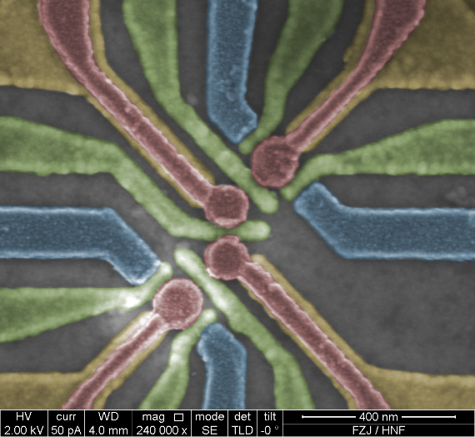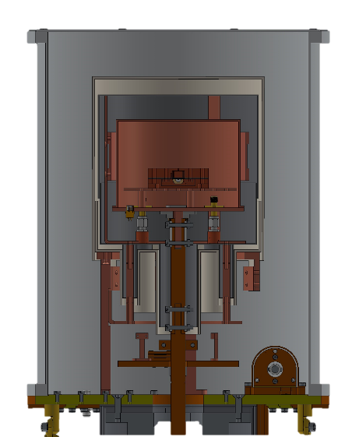
Figure 1, a) Scanning electron micrograph of a double quantum dot device on a Ge/SiGe heterostructure, b) Cross-sectional schematic of magnetic shielding installed in an ADR

[1] Scappucci, G., et al., Nat Rev Mater 6, 926–943 (2021)
[2] Hendrickx, N. W., et al., Nature volume 591, pages 580–585 (2021)
[3] Bulaev, D. V., Loss, D., PRL 98, 097202 (2007)
[4] Albrecht, W., et al., Journal of large-scale research facilities JLSRF 3, A112 (2017)

