Coherent spin shuttling in MOS quantum dots array
S.C. Lin^{1, 2}, P. Steinacker², A. Dash², T. Tanttu², A. Laucht²,
A. S. Dzurak², H.S. Goan^{1, 4, 5}, C.H. Yang^{2,}
¹Department of Physics, National Taiwan University, Taiwan
²School Electrical Engineering and Telecommunications,
University of New South Wales, Sydney, NSW 2052, Australia
⁴Center of Quantum Science and Engineering, National Taiwan University, Taiwan
⁵Physics Division, National Center of Theoretical Sciences, Taiwan

Among candidates for realizing quantum computation, Si-based quantum dots (QDs) is an attractive platform due to the potential of scaling up. The high-fidelity single- and two-qubit gates satisfying surface code requirements are demonstrated [1]. However, the conventional two-qubit gates rely on the exchange coupling of the adjacent spins and hence restrict the arrangement of qubits. A promising solution is the spin shuttling protocol [2], where the spins are moved together when needed.

The experiments are performed on MOS three QDs array. Between initialization and readout, we show the high visibility state control and long coherence time. With these elements, we demonstrate coherence spin shuttling in bucket-brigade mode. Further, we calibrate the shuttling process by repeatedly shuttling and fitting the decay rate of polarization for different initialized states and readout projections.
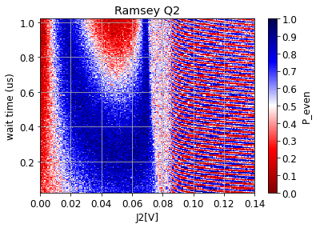 | Reference:  [1] Steinacker, P. et al. Violating Bell's inequality in gate-defined quantum dots. arXiv:2407.15778 (2024)  [2] Boter, J. M. et al. Spiderweb Array: A Sparse Spin-Qubit Array. Phys. Rev. Appl. 18, 024053 (2022)
The procession period changes due to the Larmor frequency changing at the transition line J2 ~0.08 [V].

