Nuclear Spin-Depleted, Isotopically Enriched ⁷⁰Ge/²⁸Si⁷⁰Ge Quantum Wells
Patrick Daoust¹, Patrick Del Vecchio¹, Nicolas Rotaru¹, Simone Assali¹, Anis Attiaoui¹, Gérard Daligou¹, Sebastian Koelling¹, Lu Luo¹, E. Rahier¹, Oussama Moutanabbir¹
¹Department of Engineering Physics, École Polytechnique de Montréal, Montréal, Québec, Canada

Hole spins confined in germanium (Ge) quantum wells are promising candidates for scalable qubit devices. Despite the p-symmetry of the hole wavefunction, which is associated with a weaker hyperfine interaction, recent studies show that hole qubits are still sensitive to nuclear spin background. This highlights the need for nuclear spin-free Ge qubits to suppress this decoherence channel. Herein, this work demonstrates the epitaxial growth [1], as well as the homoepitaxial regrowth [2] of ⁷³Ge- and ²⁹Si-depleted, isotopically enriched ⁷⁰Ge/silicon-germanium (SiGe) quantum wells. The growth is achieved by reduced pressure chemical vapor deposition using isotopically purified monogermane ⁷⁰GeH₄ and monosilane ²⁸SiH₄ with an isotopic purity higher than 99.9% and 99.99%, respectively. The isotopic purity is investigated using atom probe tomography (APT) following an analytical procedure addressing the discrepancies caused by the overlap of isotope peaks in mass spectra. The nuclear spin background is found to be sensitive to the growth conditions with concentrations of ⁷³Ge and ²⁹Si on the order of 0.01% in the Ge well and SiGe barriers. The measured average distance between nuclear spins reaches 3–4 nm in ⁷⁰Ge/²⁸Si⁷⁰Ge, which is an order of magnitude larger than in natural Ge/SiGe heterostructures. This demonstration of isotopically-controlled epitaxial growth of nuclear spin-free Ge/SiGe heterostructures brings the technology one step closer towards reliable and scalable hole spin qubit devices.

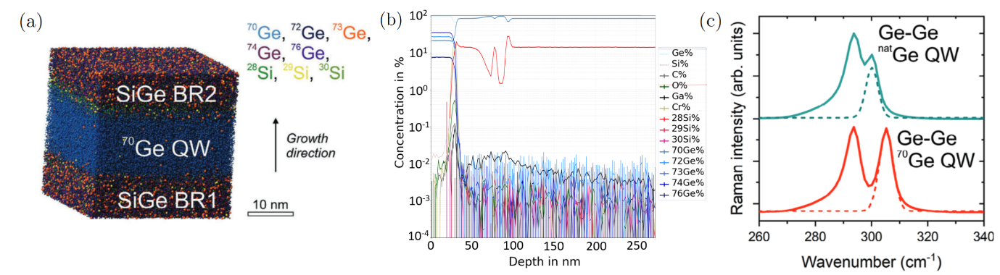
Figure 1, (a) 3D atom-by-atom APT map of an isotopically purified ⁷⁰Ge/²⁸Si⁷⁰Ge quantum well heterostructure. (b) Isotope composition extracted from APT (c) Comparison between Ge-Ge LO vibrational mode in isotopically purified ⁷⁰Ge and natural Ge QW.

[1] O. Moutanabbir et al. Advanced Materials 36, 2305703 (2024).
[2] P. Daoust, et al., In preparation

