Gate-reflectometry of Si and Ge/Si Holes
Rafael S. Eggli¹, Simon Svab¹, Dominique Trüssel¹, Taras Patlatiuk¹, Miguel J. Carballido¹, Pierre Chevalier Kwon¹, Eoin G. Kelly², Alexei Orekhov², Gian Salis², Ang Li³, Erik P. A. M. Bakkers³, Richard J. Warburton¹, Andreas V. Kuhlmann¹, and Dominik M. Zumbühl¹

¹University of Basel, Switzerland
²IBM Research – Zurich, Switzerland
³Eindhoven University of Technology, The Netherlands

Gate-dispersive reflectometry is the smallest footprint radio-frequency charge sensing technique used to perform single-shot charge and spin readout of quantum dot systems as no additional nanoscale structures are required, which is especially critical for 1-dimensional structures like nanowires or scaled, dense quantum dot arrays. This reduction in device complexity comes at the cost of less sensor tunability and more stringent requirements on the resonant tank circuit performance to achieve optimal sensitivity as compared to competing approaches like RF single-electron transistors. Here, we investigate two approaches to optimizing the gate-sensor performance with hole spins hosted in silicon fin field-effect transistors and germanium/silicon core/shell nanowires.
We introduce a novel voltage-tunable capacitor, based on quantum paraelectric strontium titanate, enabling perfect impedance matching of a tank circuit integrated with a core-shell nanowire quantum dot independent of magnetic fields beyond 2 tesla and down to 11 millikelvin [1]. We achieve fast charge readout using commercial wire-wound surface-mount inductors and observe signatures of Pauli spin blockade dispersively, paving the way towards high fidelity single-shot spin readout [2].
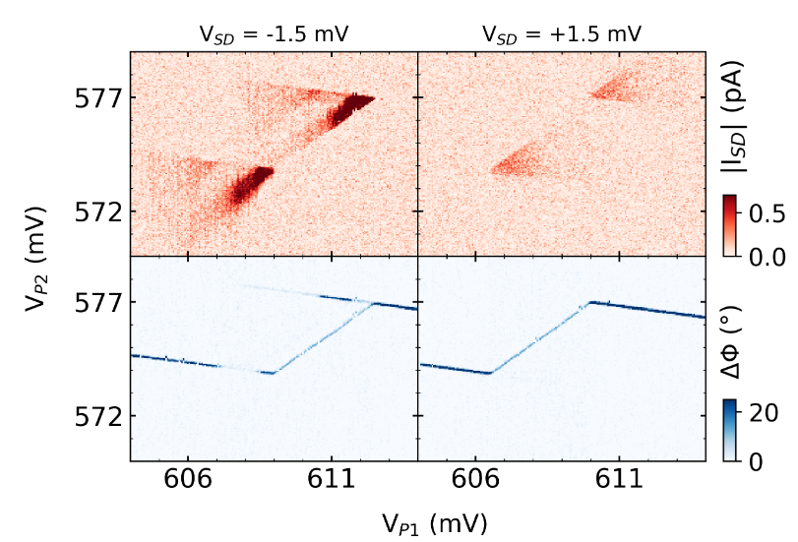
We furthermore investigate a spin qubit in a silicon fin field-effect transistor integrated with a niobium nitride nanowire inductor, whose high quality factor critically boosts the readout sensitivity. However, the high ringdown time and capacitive cross-talk leads to leakage of electrical drive signals from the qubit driving gate onto the readout gate, thus exciting the resonator and potentially affecting the qubit performance. We find a large parameter space for which resonator ring up causes a significant reduction in qubit initialisation/readout efficacy, suggesting that primarily state preparation and measurement errors are introduced. Importantly, we find that the ring up does not limit our coherence time, indicating that efficient high-Q resonators in gate sensing are compatible with all-electrical spin control [3].
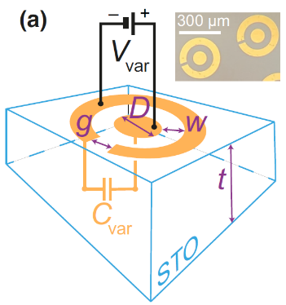
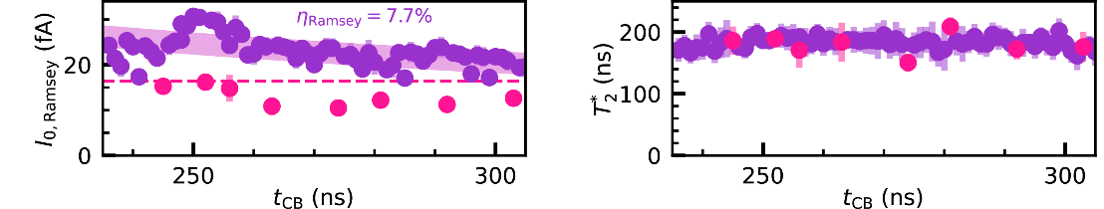

[1] R. S. Eggli, S. Svab et al. Phys. Rev. Applied 20, 054056 (2023)
[2] S. Svab, R. S. Eggli et al. in preparation.
[3] R. S. Eggli, et al. arXiv:2407.21484 (2024)

